|  |  |  |  |
| --- | --- | --- | --- |
| **Suggested Grade:** 2-3rd | **Facilitator:** | **Grade:** | **Lesson Date(s):** |
| **Book Title and Author(s)/Illustrator(s):** The Water Walker, written and illustrated by Joanne Robertson, translated by Shirley Williams and Isadore Toulouse | | | |
| **Theme(s)/Big Idea(s):** social activism, water conservation, environmentalism | | | |

|  |  |
| --- | --- |
| **VOCABULARY PLAN** | |
| **Focus word & kid-friendly definition: Conservation:** the protection of things found in nature like water, soil, minerals, animals, and trees. | |
| **Image/symbol:** Show children images of nature (end of lesson) Ask the following questions:   * Why do you think conservation might be important? Why should we protect nature? If children do not address, call out specific parts of nature with the following prompts:   + Why should we protect water?   + Why should we protect trees and plants?   + Why should we project land?   + Why should we protect animals?   + Why should we protect our air? | **Gesture:** N/A |
| **Use in context:** Give children an example of how you engage in conservation. Some examples might be turning of water when brushing your teeth, only leaving lights and tech plugged in or on when you are using them, being sure not to throw garbage on the ground, eating less meat, buying fruits and veggies from local farmers or recycling/reusing materials instead of putting them in the trash. | |
| **Prompt kids to use in context:** What are some other example of things we might do to engage in conservation or protection of nature? Prompt children to Turn and Talk or share in a whip around. | |
| **Bridge to book:** The Anishnaabe or Objiwe people believe that protecting nature is very important. Let’s read an found out how take part in conversation. | |

|  |  |  |
| --- | --- | --- |
| **BEFORE READING**  *write questions and student interaction (T/T, S/J, Act-it-out)* | | |
| * Review RR expectations * Introduce Book/Author/Illustrator * Teach focus vocab word ( See plan above) * Ask 1-2 questions to activate prior knowledge/ solicit predictions | | Explain that today we will be reading a new story called The Water Walker written and illustrated by Joanne Robertson. We are going to learn about the Anishnaabe people, also known as Objiwe. They are a First Nations people that first lived and still live in parts Canada and parts of the Midwest in the United States of America, like Minnesota, North Dakota, Wisconsin, Michigan, and Ontario. Show children maps (end of lesson) and point out these locations. Explain that we may also hear First Nations people called Indigenous, Native or Native American. Before we read, let’s learn our word of the day. *Teach focus word using the vocab plan above and then continue below.*  **Q1. The title of our story is The Water Walker. What do you think it means to be a Water Walker? (Turn and Talk)**  Prompt children to Turn and Talk. After 1-2 minutes, take a few shares from pairs. Ideas can vary but prompt children to explain responses.  **Additional Notes: This book is bilingual and includes several uses of Ojibwa words. Please review the glossary for pronunciation and definitions before you read the book aloud to your students. Be sure to have definitions ready to share verbally and/ or include them on a chart paper.** |
| **DURING READING**  *write questions and vocab with page numbers and student interaction (T/T, S/J, Act-it-out)* | | |
| * Ask 3-4 questions that target different comprehension strategies (predict, infer, connect, synthesize) * Note opportunities to reinforce focus word. * Identify other potential new vocab to define while reading | **Q1. Look at the picture very closely. What do you see?pgs.9-10 (Hands-up/Turn and Talk)**   * **Follow-up:** Nokomis said that she looked around and saw people “disrespecting water, wasting it and making it unfit for life.” What examples can you find in the pictures? * **Follow-up:** What do you think Nokomis is going to do?   *Prompt children to notice and call on volunteers to share what they see. If children share a conclusion like “People aren’t taking care of the water” instead of a detail, ask them to share what they see or notice that makes the say so. Ask first follow-up question and call on new voices. Then ask the second follow-up and prompt children to Turn and Talk. After 1-2 minutes, take a few shares from pairs.*  Q2. **Before we started reading, we made some inferences about what Water Walkers might be. Think about what we just read. What do you think Nokomis and the Water Walkers are doing?-pg. 14(Turn and Talk)**  *Prompt children to Turn and Talk. After 1-2 minutes, take a few shares from pairs.*  **Q3. Nokomis has been in movies, on TV, and spoken at large gatherings but she still notices people not protecting Nibis (water). How do you think Nokomis is feeling right now?-pg.18. (Act it out) Follow-up: What would you do if you were Nokomis?**  *Prompt children to act it out with their faces and bodies. Call out some of the emotion you see and then call on a few children to share what they acted out and why. Ask the follow-up questions and call on a few children to share.*  *.* **Q4. What are some word we could use to describe Nokomis and the other Water Walkers? (Stop and Jot)-pg. 26**  *Prompt children to Stop and Jot with words or images. After 1-2 minutes, prompt children to hold up what they wrote or draw. Call out what you see and invite a few children to share.*  **Where and how will you reinforce focus word?** *Protecting water is an act of conservation, whenever there is a mention of protecting water or having a responsibility to water – emphasize this is the act of conservation and revisit kid-friendly definition.*  **What additional words might you address while reading?**   * Pierced * Responsibility * Urgency * Devastating * Petroglyphs * Migration * Frigid   **Additional Notes: N/A** | |
| **-** | | |
| * Ask 1 question reflecting on book theme * Make connection to extension activity | | **Q1. What are some of the things Nokomis and the other Water Walkers did to protect Nibis (water)? (Turn and Talk)**  *Prompt children to Turn and Talk. After 1-2 minutes, take responses from pairs. Extend the discussion by asking other children to add more example. Revisit parts of the book if necessary. Ideas to look for: They walked to raise awareness about the importance of respecting the water; they sang and prayed for the water; They spoke on TV, made phone calls and talked to groups to talk about protecting the water.*  **Q2. What are things we could at home, at school or in our communities to conserve and protect water? (Hands-up/Volunteers)**  *Call on volunteers to share. Invite children to add new ideas. Facilitators can add to children’s ideas as well.*  **What will you say to connect theme or big idea to extension activity:**  *In our story, we learned about the love and appreciation Nokomis has for water. Water is an important resource for all animals, plants, and people and its conservation should be important for us all. This was important enough to Nokomis and her friends and family to walk for several years and several thousand miles. For today’s activity, we are use are voices and art skills to raise awareness just like Nokomis.* |

|  |  |
| --- | --- |
| **EXTENSION ACTIVITY** | |
| Activity Description- **Conservation Posters.**  Children will design a poster to help raise awareness about the importance of nature conservation. | Materials   * Construction paper in various colors * White copy paper * Crayons, markers, or colored pencils * Scissors * Glue or tape |
| Introduction  For our special activity today, we are going to design and create a conservation poster. This poster will help raise awareness about something we think is important to conserve and protect from nature. In our story, we read about how Nokomis and the other Water Walkers walked to help teach people about how important water is and why its conservation is so important. You are all going to get a chance to think about something in nature that you think is important protect and design a poster showing people why. | |
| Model  Show children several examples of conservation posters (examples at end of lesson) including ones [designed by other children](https://www.mymanatee.org/departments/utilities/manatee_county_water_division/water_conservation/kids_4_water_conservation). Invite them to explore each one with the following prompts:  • What do you notice?  • What words and images did the author use?  • What do you think the artists was trying to show us? | |
| Brainstorm (Whole group and/or Individual)  **Whole Group**  Prompt children to pretend that we were nature conservationists just like Nokomis and the Water Walkers. What are some other things in nature that we should conserve and protect? Jot down ideas on a group chart or a Jam board, if remote. (Some ideas might be: water, plants, trees, parks, animals, energy, air, land, etc. Ask children to think about ways that we might spread awareness or help others understand how important it is to protect and conserve these parts of nature?  **Individual**  Give children scrap paper or invite them to grab one if at home. Ask them to choose at least one thing in nature they think is important to protect. (They can add multiple to their posters if they choose). Ask them to think about what images and words might help others understand why this part of nature is important to protect and conserve. Invite them to practice/play around with the scrap paper as they think about a design. | |
| **Instructions for Independent Work**  Hand out poster or copy paper, coloring tools and any other art materials you would like to provide. Invite children to gather what tools they have at home, if remote. P | |
| **Share Back and Reflection**  Invite children to share their final poster in a community circle, small groups or as a Turn and Talk. Encourage them to share:   * What part of nature they chose * Why they think it is important * How they used words and images to show their message | |

**MAPS OF OBJIWE LAND AND GREAT LAKES**

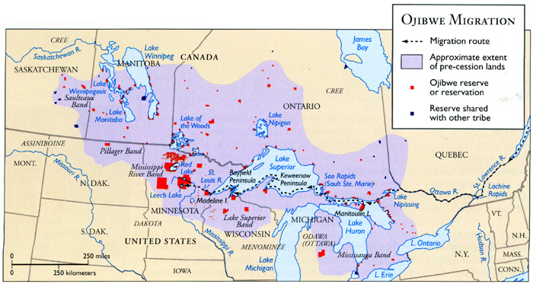

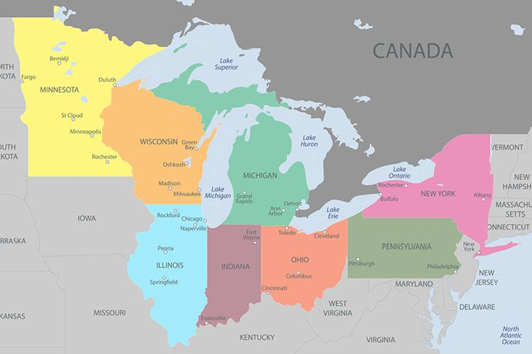

**FOCUS WORD IMAGES**

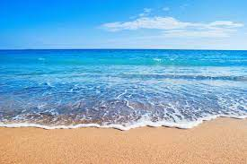

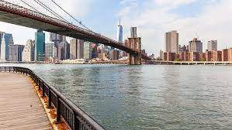 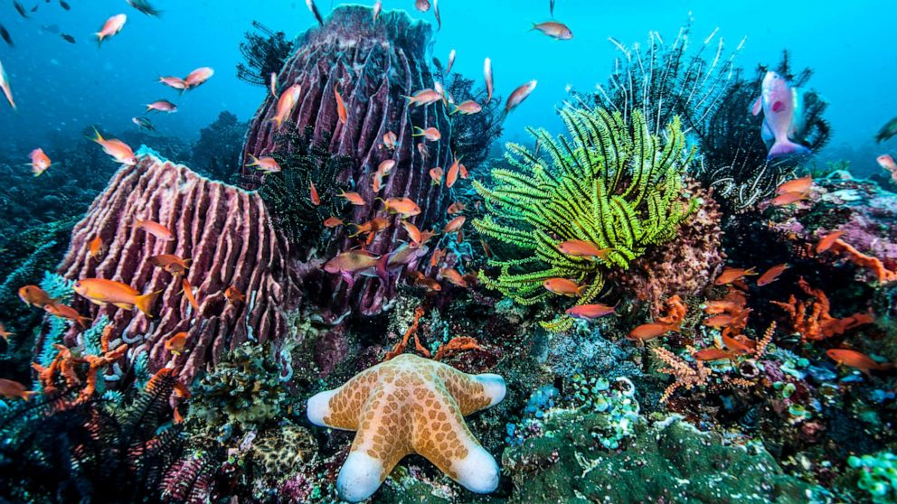

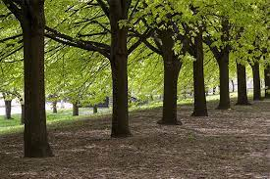

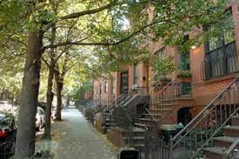

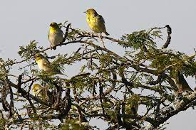

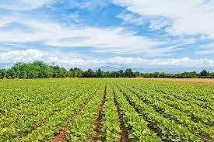

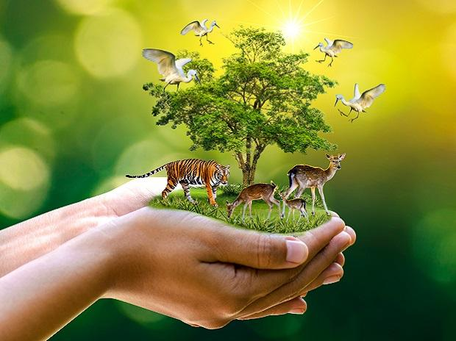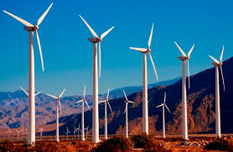

Extension Activity Models

