Suggested Grade: 2nd-3rd | Facilitator: | Grade: | Lesson Date(s):
Book Title and Author(s)/Illustrator(s): Eyes that Kiss in the Corners Written by Joanna Ho and Illustrated by Dung Ho
Theme(s)/Big Idea(s): Self-love; Confidence; Take pride in who you are; Loving yourself as you are; Different is beautiful; Family; We can get strength from our family and our culture

VOCABULARY PLAN
Focus word & kid-friendly definition- Self-love: when you love and appreciate yourself. You know that you are worthy and valuable just as you are.
Images/symbol: 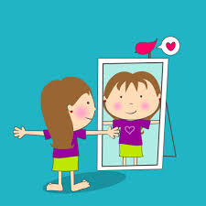 | Gesture: Invite children to give themselves a big hug and repeat the affirmation “I love myself.” You could also invite them to create their own pose or gesture for the affirmation so that they can choose what to do.
Use in context: It is so important that we have love for ourselves. While you don’t need a special reason to love yourself, I try to take some time to remember all the things that I love about myself, even when I am having a hard time. One thing that I love about myself is that I am a really good friend. I try to help others whenever I can.
Prompt kids to use in context: I want everyone to think about something they love about themselves. This could be something physical, like your smile. It could be something about your personality, like being funny or kind. It could be something you are really good at, like art! Give children time to think and then prompt them to Turn and Talk. If it’s a small group, you can have them share in a whiparound.
Bridge to book: In today’s story, we get to meet a new friend who has a lot of love for herself and her family.

BEFORE READING
write questions and student interaction (T/T, S/J, Act-it-out)
- Review RR expectations  - Introduce Book/Author/Illustrator  - Teach focus vocab word ( See plan above)  - Ask 1-2 questions to activate prior knowledge/ solicit predictions |  | Explain that we are going to be reading a new story called Eyes that Kiss at the Corners. It was written by Joanna Ho and illustrated by Dung Ho. Before we read, let’s learn our special word of the day. Teach the focus word using the vocab plan and then begin the read aloud.
DURING READING
write questions and vocab with page numbers and student interaction (T/T, S/J, Act-it-out)
- Ask 3-4 questions that target different comprehension strategies (predict, infer, connect, synthesize)  - Note opportunities to reinforce focus word.  - Identify other potential new vocab to define while reading | Q1. Simile is a special tool that writers use when comparing two things. When we write similes we compare two things using the words “like” or “as”. For example, her smile was as bright as a star or the tiger’s claw were as sharp as knives. How did the character speaking use simile to describe other people’s eyes?-pg. 2. Follow-up: Show children images of sapphires, lagoon and lace ball gowns (end of lesson). Ask why the character might have described eyes this way? (Hands-up/Volunteer)  Called on volunteers. Then prompt other children to add on new ideas. Ideas to look for: the character said that their eyes were like “sapphires, lagoons, and lace-trimmed ball gowns”; maybe the author chose these words to describe the shape, color and parts of the eyes.  Q2.Think about how the character describes her and mama’s eyes. What words does she use to describe them? How is this different from how she describes other people’s eyes?-pg. 6 (Turn and Talk)  Prompt children to Turn and Talk. After 1-2 minutes, take a few shares from pairs. Ideas to look for: she compares them to warm tea, crescent moons, and says they “kiss at the corners”.The shapes and color are different than the eyes she describes in the beginning; they are brown; they are shaped like crescent moons or almonds.  Q3. How does the character feel when talking about her, mama and Amah’s eyes? How can you tell?-pg. 12 (Act it Out)  Prompt children to act it out with their faces and bodies. Call out what you see and then invite a few children to share what they acted out and why.  Q4. The narrator has a very special relationship with her mama, Amah and her little sister, Mei-Mei. Not only do they share the same eyes, but they also care about each other. Can you think about someone that you have a special relationship with? This could be a family member, a friend, a teacher or someone else. -pg. (Stop and Jot)  Prompt children to Stop and Jot about a special relationship they have using words and images. After 1-2 minutes, prompt children to share what they wrote or drew through a Turn and Talk or a whiparound if the group is small.  Where and how will you reinforce the focus word? What additional words might you address while reading?  - sapphire  - crescent  - serene  - toddles  - revolution
AFTER READING
write questions and student interaction (T/T, S/J, Act-it-out)
- Ask 1 question reflecting on book theme  - Make connection to extension activity |  | Q1. The main character in our story had a lot of love for herself and her family. What are some things that she loved? Follow-up:How could you tell? (Turn and Talk)  Prompt children to Turn and Talk. After 1-2 minutes, take shares from pairs.  Q2. Why do you think it is important for us to practice self-love? (Hands-up/Volunteer)  Call on volunteers. Invite other children to add on to each other’s ideas.  What will you say to connect the theme or big idea to extension activity: Today we learned all about self-love through our main character’s celebration of her eyes. For our special activity, we are going to create self-portraits to celebrate our features.

EXTENSION ACTIVITY

Activity Description  Children will create self-portraits and share positive affirmations. | Materials  - Self-portrait Examples (End of Lesson)  - Blank scratch paper  - White/Cream cardstock or construction paper  - Pencils  - Coloring tools (crayons, markers, colored pencils)  - Optional: Other craft materials like yarn, construction paper, scissors and glue.  - Recommended, but optional: Photographs of each child or small mirrors for each child.
Introduction

Introduce the activity by using the transition after the read aloud. Explain that a self-portrait is a picture that someone draws of themselves.
Model

Show children examples of self-portraits. (See end of lesson) Facilitator should also prepare their own self-portrait to show along with the other samples at the end of the lesson.
Brainstorm (Whole group and/or Individual)

Explain that you are going to give them some scratch paper to practice. Then, they will get a special paper to draw and decorate their self-portrait. Hand out photographs or mirrors (If using), scratch paper and pencils. Provide 5 minutes for practice drawing.
Instructions for Independent Work

Once practice time is complete, hand out white cardstock/construction paper and coloring tools. *Facilitators can also add in other art supplies for children to enhance their portrait. Give children 20-25 minutes to work on self-portraits. Be sure to have extra cardstock just in case. Float to support.

Share Back and Reflection

Explain that an affirmation is something positive we say to encourage ourselves or other people like “I am brave” or “You are beautiful”. Explain that each person will share their portrait and something they love about themselves. This can be something physical, like your hair or your eyes or your clothes. It can be a word that describes you, like funny, smart, kind, brave or friendly. Show two sentence starters and then conduct a whip around.

- I love my____________
- I am _______________

Additional Ideas for Extension Activities

- Ode to My.... Poems (See Hair Love LP for instructions)
- "My Eyes" Blooming Flower Craft

SAPPHIRE
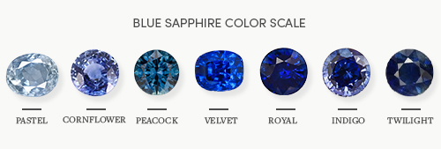

LAGOON


LACE-TRIMMED BALL GOWNS
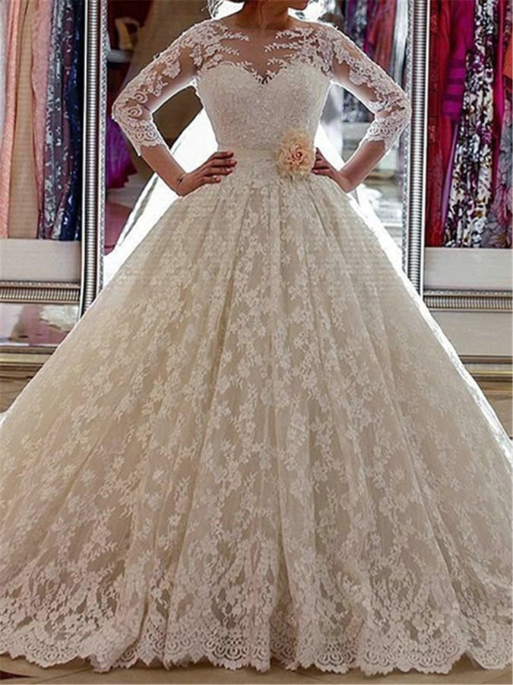

Self-Portrait Examples
