|  |  |  |  |
| --- | --- | --- | --- |
| **Suggested Grade:** K-1 | **Facilitator:** | **Grade:** | **Lesson Date(s):** |
| **Book Title and Author(s)/Illustrator(s):** A Big Mooncake for Little Star written and illustrated by Grace Lin | | | |
| **Theme(s)/Big Idea(s):** Traditions, Cultural Foods, Being Patient | | | |

|  |  |
| --- | --- |
| **VOCABULARY PLAN** | |
| **Focus word & kid-friendly definition:** Patience-waiting in a calm way | |
| **Image/Symbols:** Play Sesame Street Word of Day Video <https://www.youtube.com/watch?v=qgeuCgODgv4> | **Gesture:** N/A |
| **Use in context:** Discuss examples from the Sesame Street Video. | |
| **Prompt kids to use in context:** Can you think of a time that you were able to show patience? Prompt children to Turn and Talk. Take 1-2 shares from pairs. Then ask: What about a time that you had a hard time showing patience? Prompt children to Turn and Talk again. Take 1-2 shares from pairs. | |
| **Bridge to book:** In our story, Little Star is so excited about her Mooncake. Let’s read to see if she is able to show patience. | |

|  |  |  |
| --- | --- | --- |
| **BEFORE READING**  *write questions and student interaction (T/T, S/J, Act-it-out)* | | |
| * Review RR expectations * Introduce Book/Author/Illustrator * Teach focus vocab word ( See plan above) * Ask 1-2 questions to activate prior knowledge/ solicit predictions | | Explain that today we will be reading a new story called A Big Mooncake for Little Star written and illustrated by Grace Lin. Before we read, let’s learn our word of the day. *Teach focus word using the vocab plan above and then begin the read aloud.* |
| **DURING READING**  *write questions and vocab with page numbers and student interaction (T/T, S/J, Act-it-out)* | | |
| * Ask 3-4 questions that target different comprehension strategies (predict, infer, connect, synthesize) * Note opportunities to reinforce focus word. * Identify other potential new vocab to define while reading | **Q1.** Explain thata **mooncake** is a round cake that has a thick and sweet center. This special treat is made during the Chinese celebration known as the Mid-Autumn Festival. The moon plays an important role in this celebration. A **mooncake** is one example of special foods or treats that people eat either as a tradition or to celebrate special holidays.  **Ask: “What are other special occasions or days that you celebrate with special food or treats?** **For example, during Christmas my family makes and eats tamales and we don’t make them at any other time. pg.2 (Hands-up/Volunteer)**  *Call on volunteers to share. Prompt children to share anything they have in common with others.*  ***Q2 – What did Mama say to Little Star? (Hands-up/Volunteer) Follow-up: What do you think Little Star is going to do next? pg. 8 (Turn and Talk)***  *Prompt children to Turn and Talk. After 1-2 minutes, take a few responses from pairs. Ideas can vary, but prompt children to support answers.*  **Q3. What do you think is going to happen now? What makes you think so? -pg.16 (Hands-up/Volunteer) Follow-up: Give me a thumbs up if you agree with _____’s prediction. Give me a thumbs down if you have a different idea.**  *Call on a volunteer to share. Then, prompt children to give a thumbs up if they agree or a thumbs down if they disagree. Ask someone that gave a thumbs down to share. Idea to look for: Little Star is going to go eat more of the Mooncake*  **Q4: Look at how the Mooncake has changed as Little Star takes more and more nibbles. What do these pictures remind you of? - pgs. 25-26 (Turn and Talk)**  *Prompt children to Turn and Talk. After 1-2 minutes, take a few responses from pairs. If children don’t mention the moon or how the moon changes, ask them to think about the beginning when we first talked about the Mooncake. Remind them that we said Mooncakes are a part of a very special festival and that there is a clue right in the name Mooncake. You can also ask them what kinds of things we can see in the sky at night and if they have ever seen the moon take different shapes in the sky. Facilitators may also wish to show pictures of the moons phases and let the children compare the pictures in the book and the images of the moons phases.*  **Q5. How does mama feel when she sees that Little Star has eaten the Mooncake again? -pg. 30 (Act it Out) Follow-up: How do you think Little Star is feeling? (Hands-up/Volunteers)**  *Prompt children to act out with their faces and bodies. Call out what you see and then invite a few children to share what they acted out and why. Then, ask the follow-up question and call on volunteers. Note: Children may have the impulse to say mad, upset or angry because of the situation, but be sure to call their attention back to the clues in the story. Mama is smiling while shaking her head and giving Little Star back her bunny.*  **Where and how will you reinforce focus word?** *Focus word will be infused into the discussion question.*  **What additional words might you address while reading?**   * tiptoed * nibble * twinkling * grin | |
| **AFTER READING**  *write questions and student interaction (T/T, S/J, Act-it-out)* | | |
| * Ask 1 question reflecting on book theme * Make connection to extension activity | | **Q1. Do you think this will be the last time that Little Star will eat the Big Mooncake? Why or why not? (Turn and Talk)**  *Prompt children to Turn and Talk. After 1-2 minutes, takes a few shares from pairs.*  **Q2. Let’s think about our special word of the day. Did Little Star show patience in the story? Why or Why not? Follow-up: Why might it be a good idea to have patience? (Hands-up/Volunteer)**  *Take ideas from volunteers. Answers can vary, but children should be prompted to explain their responses.*  **What will you say to connect theme or big idea to extension activity:**  *Today we learned about how much Little Star loved Mooncake. She loved it so much that she had a hard time waiting to eat it or having patience. For today’s special activity, we are going to share foods that are special to us.* |

|  |  |
| --- | --- |
| **EXTENSION ACTIVITY** | |
| Activity Description  Children will create “plates” that show foods that they eat on special occasions or special days. | Materials   * Construction paper * Coloring tools (Crayons, markers, or colored pencils) * Scissors * Glue or tape * White paper plates * Optional: Food magazines for cutting out foods |
| Introduction  Explain that for our special activity today, we are going to make paper plates that show the foods that we eat on special occasions or special days. This could be a holiday or birthday if you celebrate these. It could also be a day that is special for you or your family. We will also write words that tell how these foods makes us feel. | |
| Model  Share your own plate of special food and share what each food is (your model should have 2-3 foods to help model and provide an example). On the back of your plate you should write words that tell how these foods make you feel or what they mean to you. You can share words like happy, excited, appreciated, loved, full, family, community, friends, etc. Sample without words below:  Image result for paper plate food drawings Image result for paper plate food drawings Image result for paper plate food drawings | |
| **Brainstorm (Whole group and/or Individual)**  Ask children to think about a holiday, birthday or special day they celebrate at home with friends, family, or in the community. Ask them to try and visualize or make a picture in their minds of the foods that they eat on this special day. Guide the visualization with the following questions:   * What do they look like? What colors do you see? * What do they smell like? * Are they hot? Are they cold? * What else is happening when you eat this food? What else happens on this special day? Is anyone else there? * Imagine what it would feel like to be eating it right now. How would that make you feel?   Prompt children to Turn and Talk to share what special day or foods they imagined. You can also have children share aloud. | |
| **Instructions for Independent Work**  Hand out paper plate, coloring tools and any other materials that you plan to provide. If remote: Invite children to complete on a paper plate if they have one or to use a blank sheet of paper. Invite children to create their plates using the materials provided. After children have completed their plates, invite them to write out words that describe how these foods make them feel or what these foods makes them think of. | |
| **Share Back and Reflection**  Invite children to share within their groups or in a circle share with the class. Facilitate a circle share with the following prompts: “A special day to me is…. My plate has the following foods on it... These foods make me think of or make me feel….” | |

|  |
| --- |
| Additional Ideas for Activities  <https://www.teachjunkie.com/sciences/21-super-activities-teaching-moon-phases/> |

**Images for talking about Mooncakes**

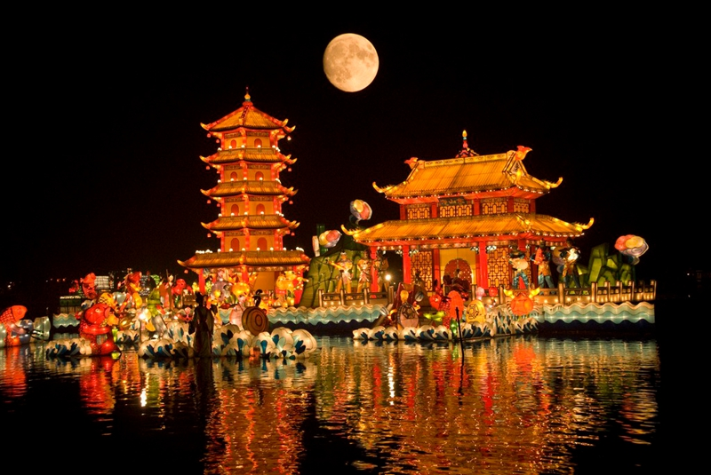

[**https://www.cnn.com/travel/article/what-is-mid-autumn-festival/index.html**](https://www.cnn.com/travel/article/what-is-mid-autumn-festival/index.html)

