|  |  |  |  |
| --- | --- | --- | --- |
| **Suggested Grade:**  1-3 | **Facilitator:** | **Grade:** | **Lesson Date(s):** |
| **Book Title and Author(s)/Illustrator(s):** The Smallest Girl in the Smallest Grade, written by Justin Roberts and illustrated by Christian Robinson | | | |
| **Theme(s)/Big Idea(s):** Bullying, speaking up, supporting others/Every voice can make a difference | | | |

|  |  |
| --- | --- |
| **VOCABULARY PLAN** | |
| **Focus word & kid-friendly definition:** Support – to give help or encouragement to someone | |
| **Image/symbol:** Picture following lesson:  The girl is showing support to her friend by reaching out to her when she feels sad. | **Gesture:**  Sometimes we feel support when someone hugs us. Can you hug yourself? |
| **Use in context:** We show our support for someone in all different ways. For example, I support my grandma by helping her with the groceries. | |
| **Prompt kids to use in context:** Can you share an example of a way that you support or help someone? Turn and talk to your partner. | |
| **Bridge to book:** Today, were are going to read a book about a little girl who doesn’t feel like her classmates support each other. | |

|  |  |  |
| --- | --- | --- |
| **BEFORE READING**  *write questions and student interaction (T/T, S/J, Act-it-out)* | | |
| * Review RR expectations * Introduce Book/Author/Illustrator * Teach focus vocab word ( See plan above) * Ask 1-2 questions to activate prior knowledge/ solicit predictions | | **Q1.** Look closely at the cover. What do you think this book may be about? Turn and talk to your partner.  *Give students ~2 minutes to talk. If necessary, remind students to switch/let their partner speak. Ask 2-3 students to share what their partner told them.* |
| **DURING READING**  *write questions and vocab with page numbers and student interaction (T/T, S/J, Act-it-out)* | | |
| * Ask 3-4 questions that target different comprehension strategies (predict, infer, connect, synthesize) * Note opportunities to reinforce focus word. * Identify other potential new vocab to define while reading | **Q1.** What do you notice happening in this picture? How would you feel if you were on this playground? Turn and talk to a partner. (pg. 2)  *Give students ~2 minutes to talk. If necessary, remind students to switch/let their partner speak. Ask 2-3 students to share what their partner told them.*  **Q2.** Can you show me with your face how Tommy feels? I see some angry faces, some sad faces, and some surprised faces. Turn and talk to your partner about why you think Tommy feels this way. (pg. 8)  *Give students ~2 minutes to talk. If necessary, remind students to switch/let their partner speak. Ask 2-3 students to share what their partner told them.*  **Q3.** Why do you think the other classmates aren’t saying anything about Kevin getting pushed off the slide? (pg. 12)  *Take popcorn responses from 2-4 students.*  **Q4.** Why is it ‘super extra special’ that Howard O’Henry supports Sally? Turn and talk to your partner. (pg. 22)  *Give students ~2 minutes to talk. If necessary, remind students to switch/let their partner speak. Ask 2-3 students to share what their partner told them.*  **Additional Notes:** | |
| **AFTER READING**  *write questions and student interaction (T/T, S/J, Act-it-out)* | | |
| * Ask 1 question reflecting on book theme * Make connection to extension activity | | Q1. How is this picture different from the first one? Turn and talk to your partner. *Turn back to the first two pages if students get stuck or confused.* (pg. 30)  *Give students ~2 minutes to talk. If necessary, remind students to switch/let their partner speak. Ask 2-3 students to share what their partner told them.*  Q2. What made the students change?  *Take popcorn responses from 2-4 students.*  **What will you say to connect theme or big idea to extension activity:**  Just like Sally and the rest of her school, we are going to think of and practice different ways to support each other.  **Additional Notes:** |

|  |  |
| --- | --- |
| **EXTENSION ACTIVITY** | |
| Activity Description  Students will learn about how to support one another by being “bucket fillers” instead of “bucket dippers.” They will brainstorm by playing a game, will decorate their own buckets, and will write notes to their classmates showing their support. | Materials  Bucket filler and dipper flash cards   * *Print double sided and cut out cards ahead of time*   “Bucket Filler Compliments” sheet  Glue or tape  Crayons  Buckets, cups & pipe cleaners, or construction paper   * *See page following lesson for instructions* * *Create a decorated sample bucket*   Decorating supplies |
| Introduction  Explain that students show support for one another by being a bucket dipper instead of a bucket filler. Explain that a bucket filler is someone who uses their actions or words to show they care, to do something kind, or to help; and that a bucket dipper is someone who uses their actions or words to hurt someone’s feelings, to be mean, or to bully. Tell students they are going to play a quick game to think about the difference between bucket fillers and bucket dippers. | |
| Model  Choose a few bucket filler/dipper flash cards to read out loud. Ask students if each action is one of a bucket dipper. If it is, place it in the decorated sample bucket. Tell students that they will be working in small groups to practice with their own examples. | |
| Brainstorm (Whole group and/or Individual)  Distribute the remaining flashcards to small groups of 4-5 students. Allow them to practice by deciding as a group which actions would be bucket filling and which would be bucket dipping. Bucket filling actions can be placed in the bucket. Bucket dipping actions can be placed in a pile. *Younger students may need help reading the scenarios. This can also be done as a whole class depending on the age/reading level of the students.*  **If you are following a two-day model, collect the buckets and flash cards and stop here.** | |
| Instructions for Independent Work  **If you are following a two-day model, start here. Welcome students back and review the previous lesson. If time permits, re-read the book.**   1. Explain that students will make their own buckets and will write notes to each other so that they can fill someone else’s bucket. 2. Distribute “Bucket Filler Compliments” templates. Each student should have one. Instruct students to write a small note or compliment to a classmate. Assign each student a classmate to write to, ensuring that everyone will receive a note in their bucket. 3. Collect the compliments and distribute buckets and decorating supplies. As each student decorates their bucket, place the compliments inside. | |
| Share Back and Reflection  Allow students to read and share their compliments. Explain that now that their buckets are filled, it is their job to fill others’ buckets by being supportive. | |

|  |
| --- |
| Additional Ideas for Extension Activities  Create a class bucket that can be filled throughout the year with positive actions that students take. |

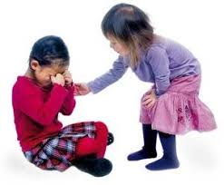Image for Support

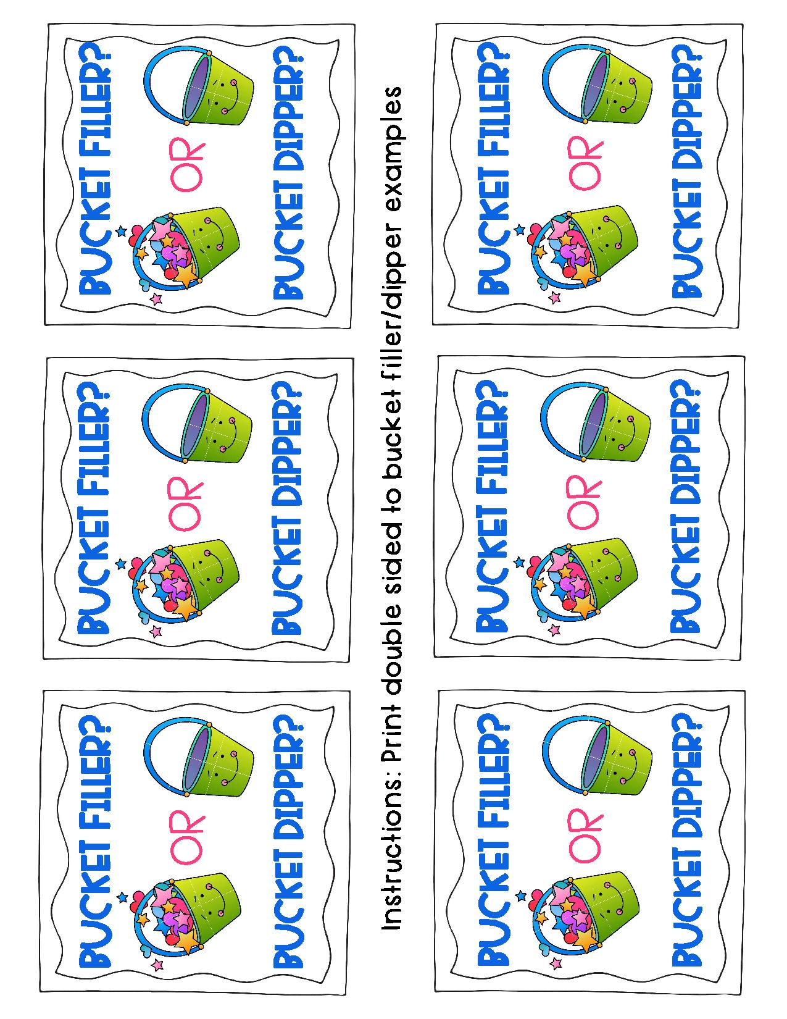

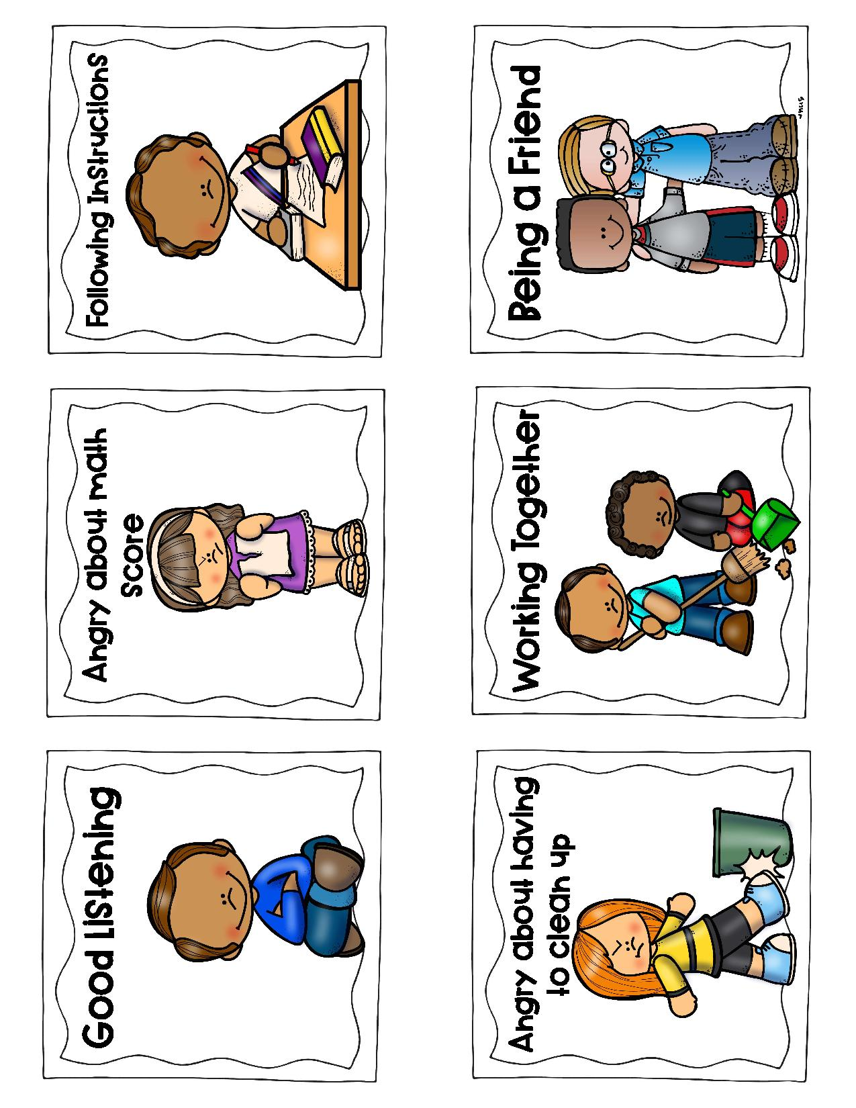

Group 1

Group 2

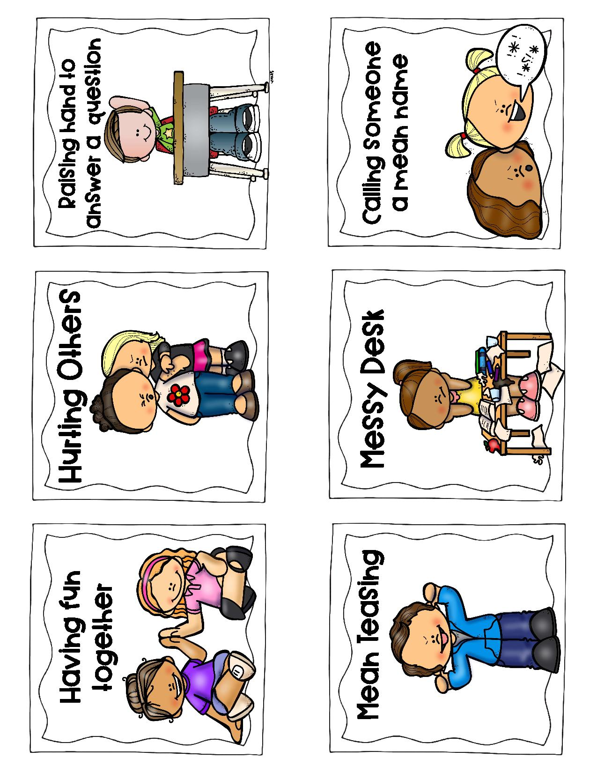

Group 3

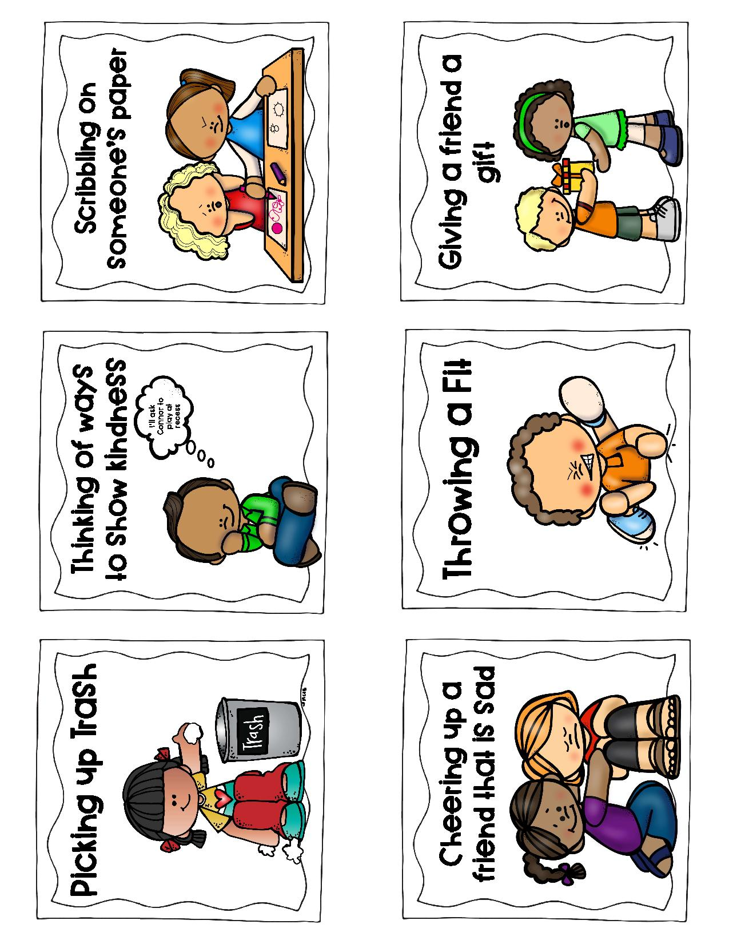

Group 4

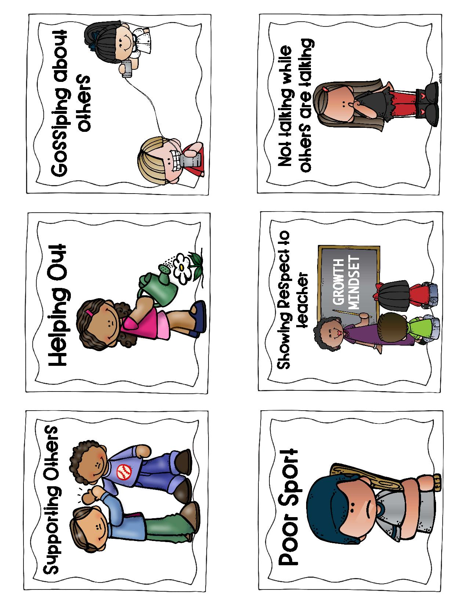

Group 5

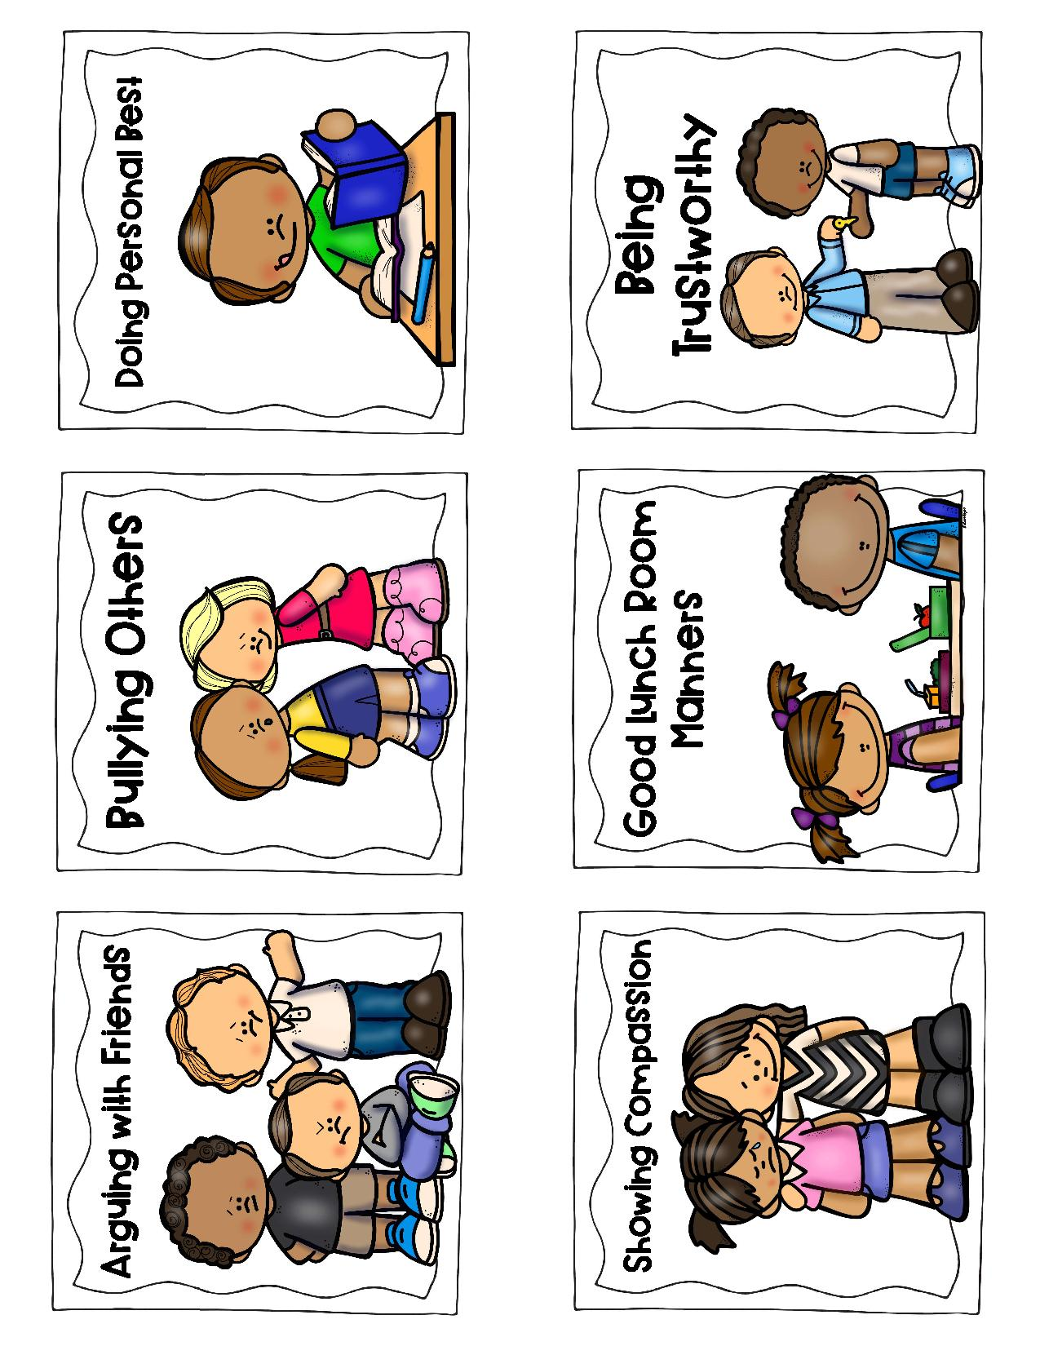

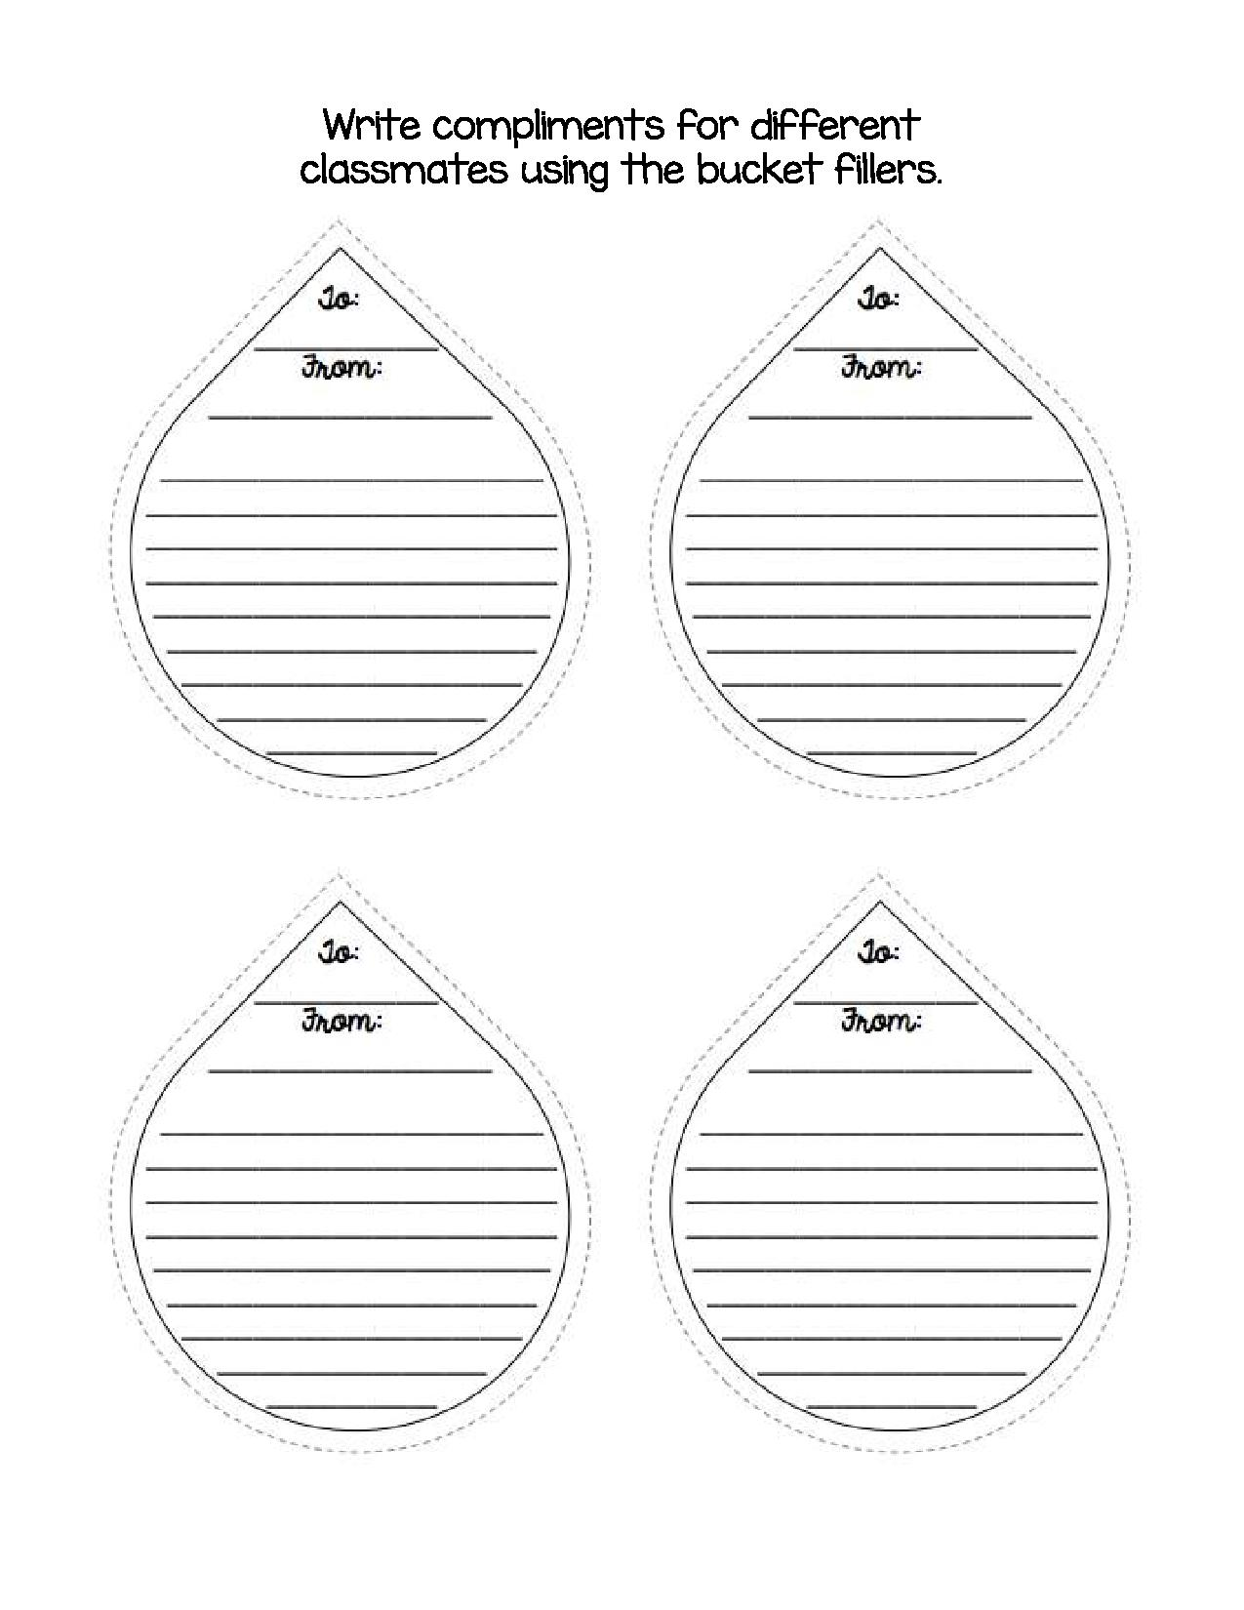

Bucket Options

1. 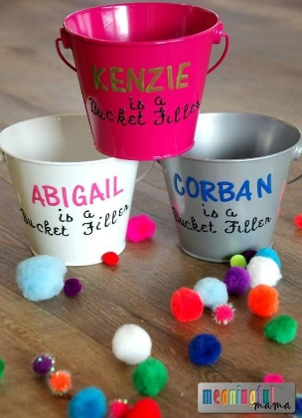Purchase plastic buckets that students can decorate.

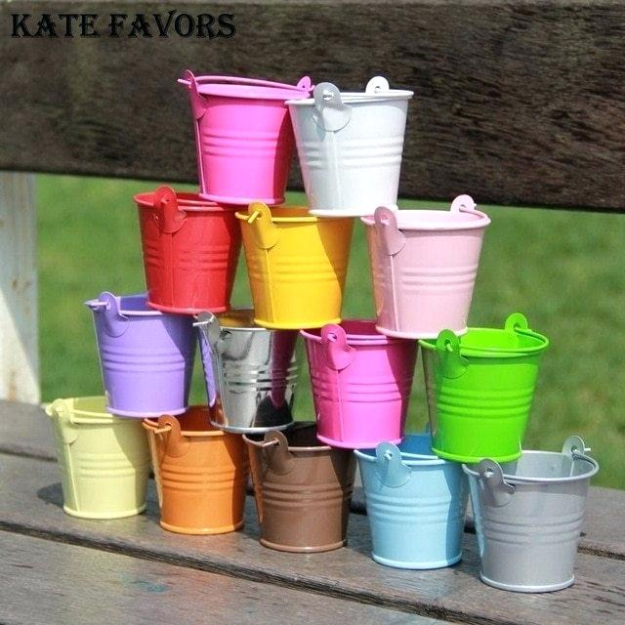

1. Make paper buckets (instruction on next page).

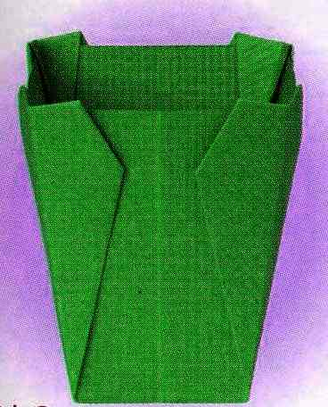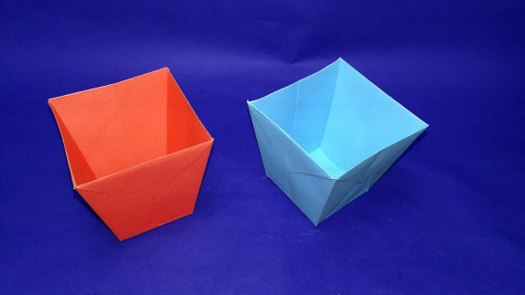

1. Use cups to make buckets by either:
   1. Punching two holes on both sides and looping a pipe cleaner through.
   2. Stapling a strip of paper across the top.

