|  |  |  |  |
| --- | --- | --- | --- |
| **Suggested Grade:** K-2nd | **Facilitator:** | **Grade:** | **Lesson Date(s):** |
| **Book Title and Author(s)/Illustrator(s):** The Adventures of Beekle - Author and illustrator: Dan Santat | | | |
| **Theme(s)/Big Idea(s):** Everyone can overcome obstacles; perseverance and determination; friendship is important | | | |

|  |  |
| --- | --- |
| **VOCABULARY PLAN** | |
| **Focus word & kid-friendly definition:** Adventure - a wild and exciting mission; a risk in the hope of a favorable outcome | |
| **Image/symbol:** see attached* | **Gesture:** n/a |
| **Use in context:** The two people in the picture are going on a big adventure up a mountain. | |
| **Prompt kids to use in context:** What adventures have you taken part in recently? | |
| **Bridge to book:** In this story, we meet an unimaginary friend who goes on a big adventure to find their perfect friend match. | |

|  |  |  |
| --- | --- | --- |
| **BEFORE READING**  *write questions and student interaction (T/T, S/J, Act-it-out)* | | |
| * Review RR expectations * Introduce Book/Author/Illustrator * Teach focus vocab word ( See plan above) * Ask 1-2 questions to activate prior knowledge/ solicit predictions | | *Beekle is patiently waiting his turn to be chosen by a real child, but when he is overlooked time and again, he sets off on an incredible journey to the bustling city, where he finally meets his perfect match and - at long last - is given his special name: Beekle.*  **Q1.**  Why do children sometimes have ‘imaginary friends’? Have you got one or ever had one? If so, why?  *Give students ~2 mins to turn & talk. Ask 3 students to share their responses (~3 mins).*  **Q2.**  What is the craziest, most creative thing that you have ever imagined?  *Give students ~2 mins to turn & talk. Ask 3 students to share their responses (~3 mins).* |
| **DURING READING**  *write questions and vocab with page numbers and student interaction (T/T, S/J, Act-it-out)* | | |
| * Ask 3-4 questions that target different comprehension strategies (predict, infer, connect, synthesize) * Note opportunities to reinforce focus word. * Identify other potential new vocab to define while reading | **Q1.** Pg. 12 - What is imaginary friend doing here? Where do you think he is going? Use the pictures to help you understand.  *Take 1-3 popcorn answers. Students should be able to infer that the imaginary friend is going on a big adventure to find a friend since no one had imagined him yet. Follow up answers by asking “How do you know” to students. Then ask the following question.*  This imaginary friend seems to be going on a big adventure to find his friend, and the thought of making a friend keeps him going. What does this tell us about him and his character? What words would you use to describe him? Turn and talk with your partner.  *Give students ~3 minutes to discuss. Listen for students discussing that the imaginary friend is brave, courageous, and never gives up. Ask 2-3 students to share their responses.*  **Q2.** Pg.16 – How does the imaginary friend feel when he reaches the real world? Show me with your faces how he feels.  *Narrate what you see students acting out to reinforce their inferences. For example: “I see you making a confused face. I agree that the imaginary friend seems confused. I would probably be confused too if I just arrived in a new world.”*  **Q3.** Pg. 24 - The imaginary friend is sitting by himself at the top of the tree. On your whiteboards or journals, stop and jot about how he is feeling and why he feels that way.  *Give students ~2-3 minutes to write. Let 2-3 students share their answers. Provide a sentence stem such as, “He feels ___________ because_______________.” if necessary for students.*  **Q3.**  Pg. 31 - Making new friends can be hard. Look closely at the illustrations showing Beekle and Alice meeting. How did Beekle and Alice overcome their difficulties and get to know each other? How have you made a friend before?  *Give students ~3 minutes to turn and talk. Ask 3 students to share their responses.*  **Where and how will you reinforce focus word? What additional words might you address while reading?**   * Reinforce focus word in Q1. | |
| **AFTER READING**  *write questions and student interaction (T/T, S/J, Act-it-out)* | | |
| * Ask 1 question reflecting on book theme * Make connection to extension activity | | **Q1.**  How did being friends make Alice and Beekle feel? Why are friends so important in our lives? What is the nicest thing that you have done for a friend? What is the nicest thing a friend has done for you?  *Give students ~3 minutes to turn & talk. Take 2-3 student responses.*  **What will you say to connect theme or big idea to extension activity:**  In our story each imaginary friend matched the personalities and interest of their human friend. Today we will draw a portrait of ourselves and an imaginary friend that reflects our interest and personalities. |

|  |  |
| --- | --- |
| **EXTENSION ACTIVITY** | |
| **Activity Description**  Portrait with imaginary friends – each student will draw a self-portrait and include an imaginary friend who reflects their interest and personalities. | **Materials**   * Poster board * Chart paper * Pencils * Art supplies (markers, colored pencils) |
| **Introduction**  Examine the end pages of *The Adventures of Beekle* (you will need to obtain a hardcover copy of the book). They depict cameo images of children and their imaginary friends. Your students will notice that that the humans and imaginary friends are clearly connected. For example, a young boy depicted holding a kite is accompanied by a cloud, and a young girl wearing water wings has an oversized fish sporting a sailor’s cap next to her. Ask your students to create portraits of themselves with their own imaginary friends. How are their interests and talents reflected in the images? Create a display for all to enjoy. | |
| **Model**  On chart paper create a web with your name in the middle. Model for students thinking out loud about your own personalities traits and interests. Chart your own responses on the web so that all students can see. | |
| **Brainstorm (Whole group and/or Individual)**  Ask students to create a web in their journal with their name in the middle of the web. Tell students to jot down their interest and personality traits around the web. Students should use writing notebooks to record their brainstorming. Give students ~7-10 minutes to brainstorm together. Ask 3-7 students to share ideas. | |
| **Instructions for Independent Work**  Hand each student a poster board or large piece of paper. Instructs students to write their name on the back. Tell students that they should draw a portrait of themselves and they should draw an image of their imaginary friend beside it. Remind students that their imaginary friend should reflect their personality and interest and they should use their brainstorming sheet for ideas. Explain to students they should use all the space on their poster board. Students should complete the following short sentences at the bottom of their board (note: copy this sentence frame onto the whiteboard or a piece of chart paper for students to reference).  My name is _______________________. My imaginary friend’s name is____________________. We like ____________, __________________, and _________________. One special thing you should know about us is _______________________________. | |
| **Share Back and Reflection**  Let 3-4 students share their finished poster boards. If possible, display all boards in a public space.  *Reflection Question:* Ask students to talk with a partner – How is your imaginary friend connected to you? | |

**VOCABULARY IMAGE – ADVENTURE**

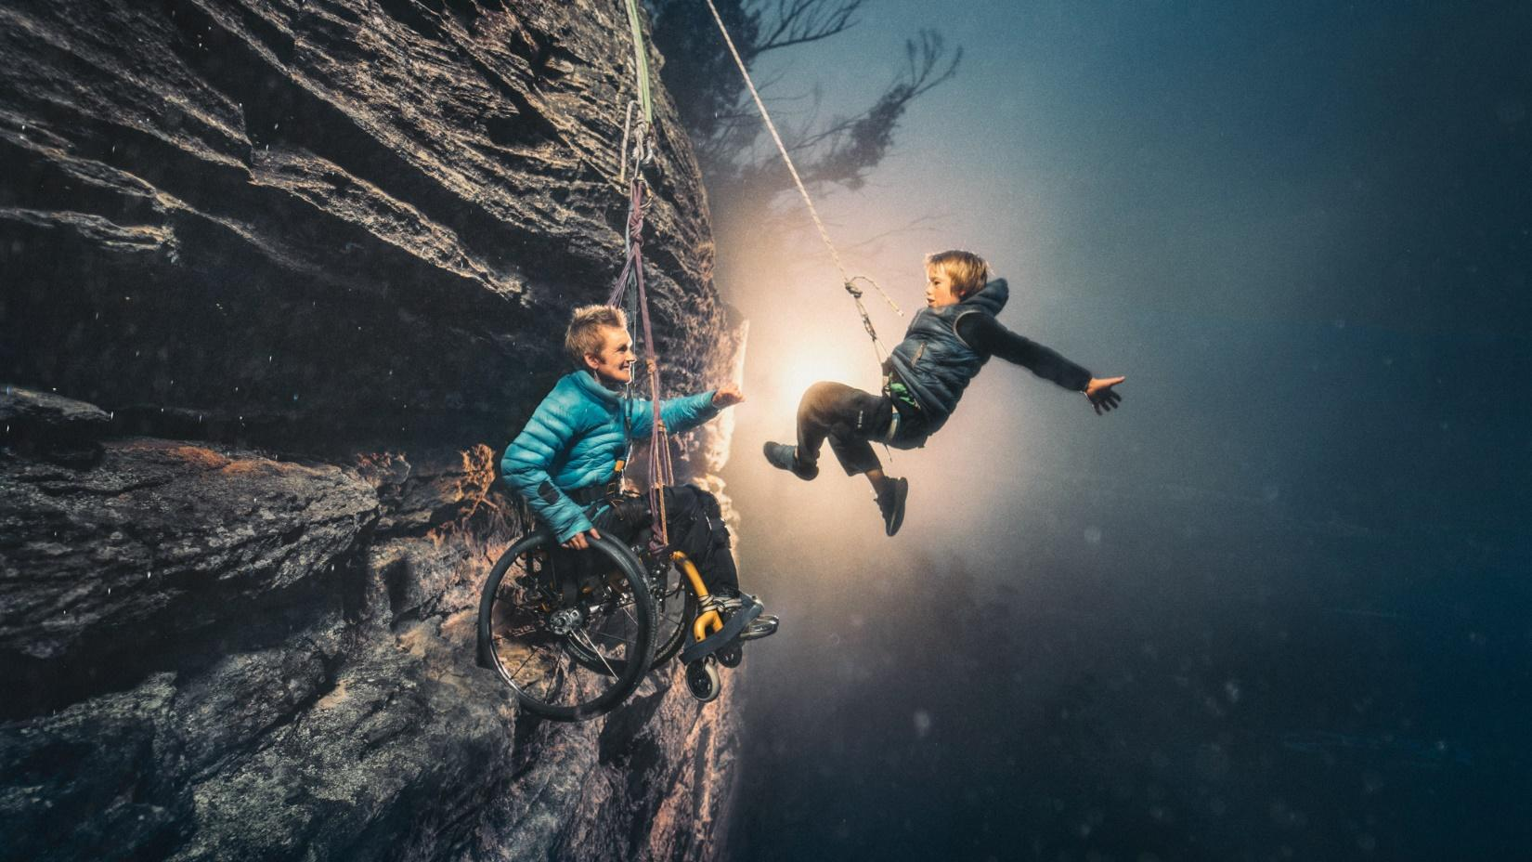

**MODEL**

