Suggested Grade:  1st-3rd | Facilitator: | Grade: | Lesson Date(s):
Book Title and Author(s)/Illustrator(s): Sulwe Written by Lupita Nyong’O and Illustrated by Vashti Harrison
Theme(s)/Big Idea(s): Self-love; Self-acceptance; People of all skin tones and colors are beautiful; Love yourself as you are.

NOTE: This book covers sensitive topics like colorism, bullying based on skin color, and low self-esteem based on appearance. It may be helpful to review community agreements beforehand with an emphasis on using kind words and showing empathy for others. Facilitators should also be sensitive to children who may feel negatively triggered by parts of the story and be prepared to provide support and affirmation. It is also important to reinforce that it is never okay to tease or treat someone badly because of how they look and that people of all shades, shapes and sizes are beautiful. Be prepared to intervene and address any harmful comments that may come up firmly and with a clear explanation. Facilitator may also wish to dig a little deeper into the concepts of colorism, prejudice and bias. For additional context and guidance on discussing these topics, facilitators can check out these additional guides and articles:

Sulwe Educator Discussion Guide_ADL

Sulwe_Parent and Family Discussion Guide_ADL

https://www.tolerance.org/magazine/recognizing-and-addressing-colorism-in-schools

https://www.adl.org/education/resources/tools-and-strategies/talking-to-young-children-about-prejudice

VOCABULARY PLAN
Focus word & kid-friendly definition: Pride means having a feeling of being good and worthy. It means having a feeling of self-respect.

Image/symbol: Show children the pictures at the end of the lesson. Ask them to notice what brings each person pride. | Gesture: N/A
Use in context: Facilitator should share an example of something that gives them pride or makes them feel proud.
Prompt kids to use in context: Prompt children to think of something that gives them pride or that they are proud of. Call on a few volunteers to share ideas.
Bridge to book: Our main character Sulwe is having a hard time feeling pride in herself. As we read, let’s see what lessons she learns.

BEFORE READING
write questions and student interaction (T/T, S/J, Act-it-out)
- Review RR expectations  - Introduce Book/Author/Illustrator  - Teach focus vocab word ( See plan above)  - Ask 1-2 questions to activate prior knowledge/ solicit predictions |  | Explain that today we are going to reading a very special story called Sulwe. It was written by an award-winning actress and writer named Lupita Nyong’o. You may have seen her in the movie Black Panther. (Facilitators may also show a picture) It was illustrated by Vashti Harrison. Explain that before we read, we are going to learn our special word of the day. Teach focus word using the vocab plan above and then begin the read aloud.
DURING READING
write questions and vocab with page numbers and student interaction (T/T, S/J, Act-it-out)
- Ask 3-4 questions that target different comprehension strategies (predict, infer, connect, synthesize)  - Note opportunities to reinforce focus word.  - Identify other potential new vocab to define while reading | Q1. What do you notice about Sulwe and her family? How are they similar or the same? How are they different from each other?-pg.3 (Hands-up/Volunteer)  Take noticings from children. Ideas to look for: Baba has on glasses; Mama and Mich have braids, but Sulwe and Baba have short haircuts; Mama, Baba, and Mich are smiling, but Sulwe isn’t; They also have different skin tones or shades of brown skin  Note: When addressing the different shades of skin in Sulwe’s family, it may be helpful to explain what melanin is. Melanin is pigment (color) that gives skin, hair and eyes their color. Everyone is born with melanin, but not everyone has the same amount. Dark-skinned people have more melanin in their skin than light-skinned people.  Q2. Have you ever felt like Sulwe? If so, when did you feel this way?-pg.5 (Hands-up/Volunteer)  Invite any children that are comfortable to sharing. Be sure to thank each child for being brave enough to share.  Q3. How does Sulwe feel about the color of her skin? How do you know she feels this way?-pg.8 (Turn and Talk) Follow-up: Why does she feel this way? (Hands-up/Volunteer)  Prompt children to Turn and Talk. After 1-2 minutes, take a few shares from pairs. Ideas to look for: It makes her feel sad or unhappy; She wants to have lighter skin; We can tell because she tries to make herself lighter by erasing her skin, putting on makeup, eating light-colored food and praying for lighter skin. She feels this way because she looks different from her family, because the other children tease her and because she doesn’t have friends like her sister Mich. If children forget details, go back and reference the story.  Q3. What do you think Mama means when she says beauty starts with “how you see yourself, not how others see you?”-pg. 13 (Hands-up/Volunteer)  Take ideas from volunteers. Ideas to look for: it is important to like and love ourselves; how we feel about ourselves is important; it is important to love yourself no matter what other people think. Facilitator should share this as a think aloud, if children get stuck.  Q4. What do you think happened when Night got fed up and walk off of the earth?-pg.23 (Turn and Talk)  Prompt children to Turn and Talk. After 1-2 minutes, take a few ideas from pairs. Answer can vary.  Q5. Why is Night important? Why do people need her?-pg. 29 (Hands-up/Volunteers)  Take ideas from volunteers. Prompt for additional ideas. Ideas to look for: To cool off on hot days; to sleep and get rest; to see the lights that only come out at night (stars, moon) Refer back to pictures and story if needed to gather examples.  Q6. How is Sulwe feeling?-pg.36 (Act it Out)  Prompt children to act out with their faces and bodies. Call out what you see and invite a few children to share.  Where and how will you reinforce focus word? What additional words might you address while reading? Focus word will be reinforced through discussion questions.  Additional words:  - Elegant  - Rejoice  - Comply  - Inseparable  - Mutter  - Dusk  Additional Notes: N/A
AFTER READING
write questions and student interaction (T/T, S/J, Act-it-out)
- Ask 1 question reflecting on book theme  - Make connection to extension activity |  | Q1. How did Sulwe’s feelings about herself change? (Turn and Talk)  Prompt children to Turn and Talk. After 1-2 minutes, take a few shares from pairs. Ideas to look for: She didn’t like the color of her skin in the beginning and tried to change it. In the end, she thought that her skin was beautiful. She loved herself more in the end and realized that she had brightness in her. She has more pride.  Q2. What did Sulwe learn from the dream that she has about the sisters, Night and Day? Follow-up: What can we learn from Sulwe’s story? (Hands-up/Volunteers)  Take ideas from volunteers. Prompt other children to respond or add on to ideas. Ideas to look for: She learns that both day and night/light and dark are special, beautiful and important in their own way; She learns that her dark skin is special, beautiful and important just like the Night. We can learn that all different shades of skin are beautiful and that we all kinds of people are special.  What will you say to connect theme or big idea to extension activity: Sulwe learned that her dark skin was beautiful and that she is special just the way she is. Just like Sulwe’s mama said, it is important that we love ourselves. This could mean loving how we look on the outside and the person we are on the inside. For today’s special activity, we are going to celebrate what’s unique about each of us with self-portraits and affirmations.

EXTENSION ACTIVITY

Activity Description  Children will create self-portraits and share positive affirmations. | Materials  - Self-portrait Examples (End of Lesson)  - Blank scratch paper  - White/Cream cardstock or construction paper  - Pencils  - Coloring tools (crayons, markers, colored pencils)  - Optional: Other craft materials like yarn, construction paper, scissors and glue.  - Recommended, but optional: Photographs of each child or small mirrors for each child.
Introduction

Introduce the activity by using the transition after the read aloud. Explain that a self-portrait is a picture that someone draws of themselves.
Model

Show children examples of self-portraits. (See end of lesson) Facilitator should also prepare their own self-portrait to show along with the other samples at the end of the lesson.
Brainstorm (Whole group and/or Individual)

Explain that you are going to give them some scratch paper to practice. Then, they will get a special paper to draw and decorate their self-portrait. Hand out photographs or mirrors (If using), scratch paper and pencils. Provide 5 minutes for practice drawing.
Instructions for Independent Work

Once practice time is complete, hand out white cardstock/construction paper and coloring tools. *Facilitators can also add in other art supplies for children to enhance their portrait. Give children 20-25 minutes to work on self-portraits. Be sure to have extra cardstock just in case. Float to support.

Share Back and Reflection

Explain that an affirmation is something positive we say to encourage ourselves or other people like “I am brave” or “You are beautiful”. Explain that each person will share their portrait and something they love about themselves. This can be something physical, like you hair or your eyes or your clothes. It can be a word that describes you, like funny, smart, kind, brave or friendly. Show two sentence starters and then conduct a whip around.

- I love my____________
- I am _______________

Additional Ideas for Extension Activities

- Name acrostic poems or Bio poems

Focus Word Images

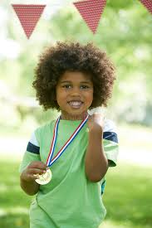



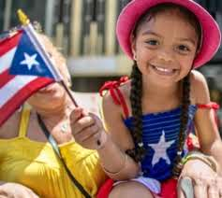

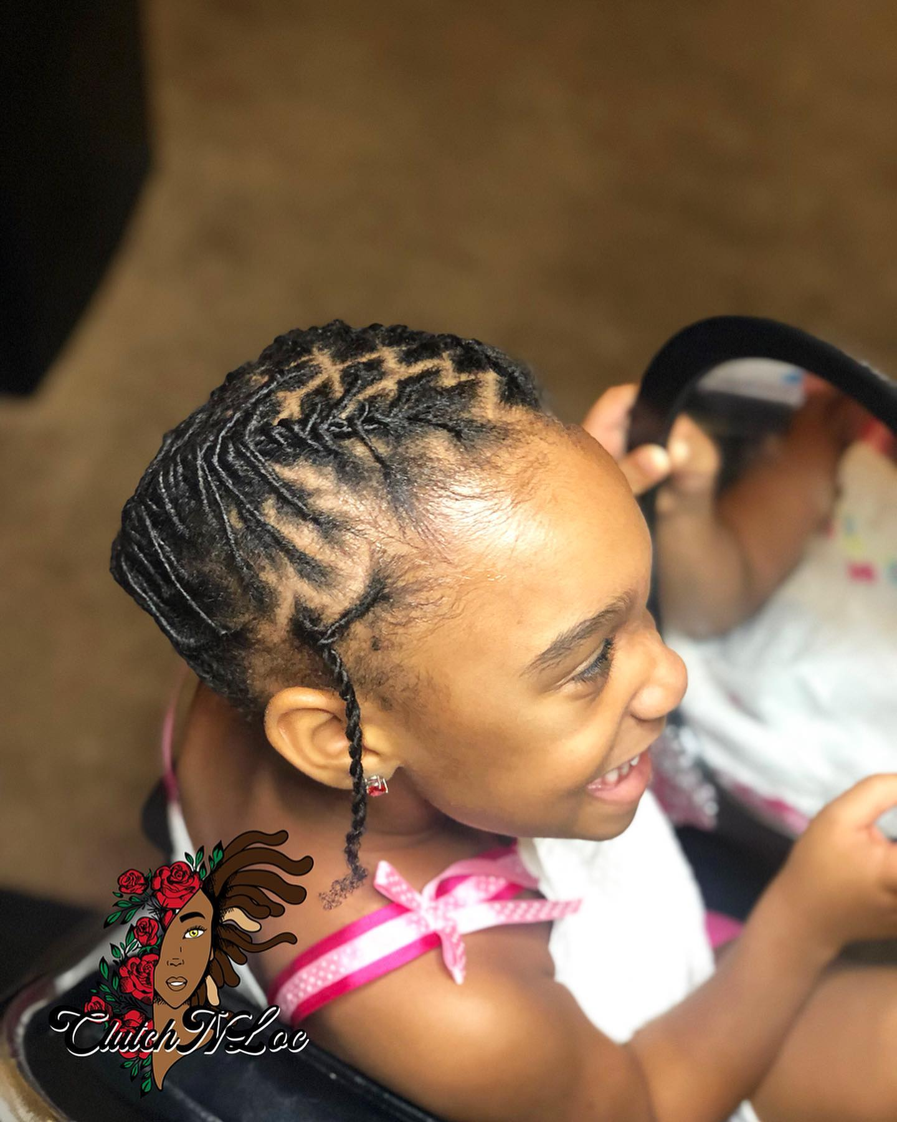

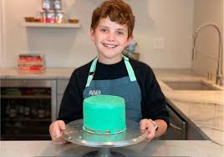

Self-Portrait Examples
