|  |  |  |  |
| --- | --- | --- | --- |
| **Suggested Grade:** 1-3 | **Facilitator:** | **Grade:** | **Lesson Date(s):** |
| **Book Title and Author(s)/Illustrator(s):** Say Something, written and illustrated by Peter H. Reynolds | | | |
| **Theme(s)/Big Idea(s):** It is important to speak up about what you believe in, there is more than one way to use your voice | | | |

|  |  |
| --- | --- |
| **VOCABULARY PLAN** | |
| **Focus word & kid-friendly definition:** Voice: expressing a wish, choice or opinion | |
| **Image/symbol:** Picture following lesson:  This is a picture of a real children’s march that happened in 1963. Many children were being treated unfairly, so they made signs and marched around their city to try and create chance. | **Gesture:** |
| **Use in context:** The word “voice” can mean the sounds that come out of your mouth when you speak, but today we’re going to talk about the word “voice” a little differently. “Voice” can also mean the way you express something important. For example, making a YouTube video is one way to express an idea. | |
| **Prompt kids to use in context:** Can you think of an example of a way to communicate with someone without taking? | |
| **Bridge to book:** Today we are going to read about different ways that kids just like you use their voices to say something! | |

|  |  |
| --- | --- |
| **BEFORE READING**  *write questions and student interaction (T/T, S/J, Act-it-out)* | |
| * Review RR expectations * Introduce Book/Author/Illustrator * Teach focus vocab word (See plan above) * Ask 1-2 questions to activate prior knowledge/ solicit predictions | **Q1.** Saying something means getting a message across; it doesn’t always mean talking out loud. Can someone share an example of a way to communicate with someone without talking?  *Take popcorn responses from 2-4 students.*  **Additional Notes:** |
| **DURING READING**  *write questions and vocab with page numbers and student interaction (T/T, S/J, Act-it-out)* | |
| * Ask 3-4 questions that target different comprehension strategies (predict, infer, connect, synthesize) * Note opportunities to reinforce focus word. * Identify other potential new vocab to define while reading | **Q1.** What do you think it means to speak from the heart? Turn and talk to a partner. (pg. 2)  *Give students ~2 minutes to talk. If necessary, remind students to switch/let their partner speak. Ask 2-3 students to share what their partner told them.*  **Q2.** How can you say something through action without using your words? (pg. 4)  *Take popcorn responses from 2-4 students.*  **Q3.** Draw a picture on your whiteboard or notebook that shows how you feel right now. (pg. 8)  *Give students 2-3 minutes to draw/write. Let 2-3 students share their response.*  **Q4.** Act like you just had a great idea and show me your strong, confident poses! (pg. 16)  **Where and how will you reinforce focus word? What additional words might you address while reading?**  Express – to make something known  Action – doing something  Lonely – sad feelings from being alone  Injustice – unfair treatment  Inspire – to cause something to occur, be created, or done  **Additional Notes:** |
| **AFTER READING**  *write questions and student interaction (T/T, S/J, Act-it-out)* | |
| * Ask 1 question reflecting on book theme * Make connection to extension activity | Q1. What were some of the ways the kids in this story used their voice to say something? *Make a list of student responses.*  **What will you say to connect theme or big idea to extension activity:**  Just like the kids in the story, we’re all going to use our voices to say something about things that are important to us!  **Additional Notes:** |

|  |  |
| --- | --- |
| **EXTENSION ACTIVITY** | |
| Activity Description  Students will have the opportunity to use their voice by signing the “Say Something” pledge and creating a large speech bubble cutout. | Materials  Chart paper and markers (*create a sample pledge on chart paper)*  “Say Something” pledge handout  Pencils  Crayons/Markers/Colored pencils  Oaktag, poster board, or cardstock  Popsicle sticks or long dowels  Scissors  Glue  Sample speech bubble on stick (*made ahead of time)* |
| Introduction  Just like the children in the book we read, we are going to use our voices to say something about things that are important to us. *Show sample speech bubble*. We are all going to make these to remind us about sharing our ideas with others. But first, we are going to brainstorm some ways we can say something without words. | |
| Model  *Hand out copies of pledge*. We’re going to think about some ways that we can say something without words. When I think about seeing someone lonely, I think about sitting with them and maybe playing a game. I’m going to write/draw that in the first bubble. Can someone give an example of what they could say without words if they see an injustice? *Take a few answers and write/draw one in the second bubble.* What could you do if you saw something beautiful? *Take a few answers and write/draw one in the second bubble*. Now it’s your turn! | |
| Brainstorm (Whole group and/or Individual)  Instruct students to either draw or write their own ideas into the bubbles on the pledge. Challenge them not to use the same ideas on the board. Give them ~5 minutes to discuss their ideas as group before working individually.  **If you are following a 2-day model, collect the completed pledges and continue the rest of the lesson the next day.** | |
| Instructions for Independent Work  **If you are following a 2-day model, start here. Welcome students back and review the previous lesson. If time permits, re-read the book. Hand out the completed pledges.**  For older students: Distribute oaktag/poster board/card stock and instruct them to draw and cut out a large speech bubble. Allow them time to write or draw a message that means something to them. Encourage them to use the pledge or a moment from the book as inspiration if they cannot think of something to write/draw. These should be colored in and decorated.  For younger students: Create large speech bubbles ahead of time and distribute. Write sentence stems (“This year, I will say something by ___________,” “If I see ______________, I will ________________,” etc.) Allow them time to write or draw a message that means something to them. Encourage them to use the pledge or a moment from the book as inspiration if they cannot think of something to write/draw. These should be colored in and decorated. | |
| Share Back and Reflection  Allow students to share with the whole class or in small groups. Tell them you hope everyone continues to use their voice and share their ideas just like they did today. | |

|  |
| --- |
| Additional Ideas for Extension Activities   * “What Will You Say?” class chart   + This can also be made into a game using small speech bubbles and popsicle sticks. |

Image for “Voice”

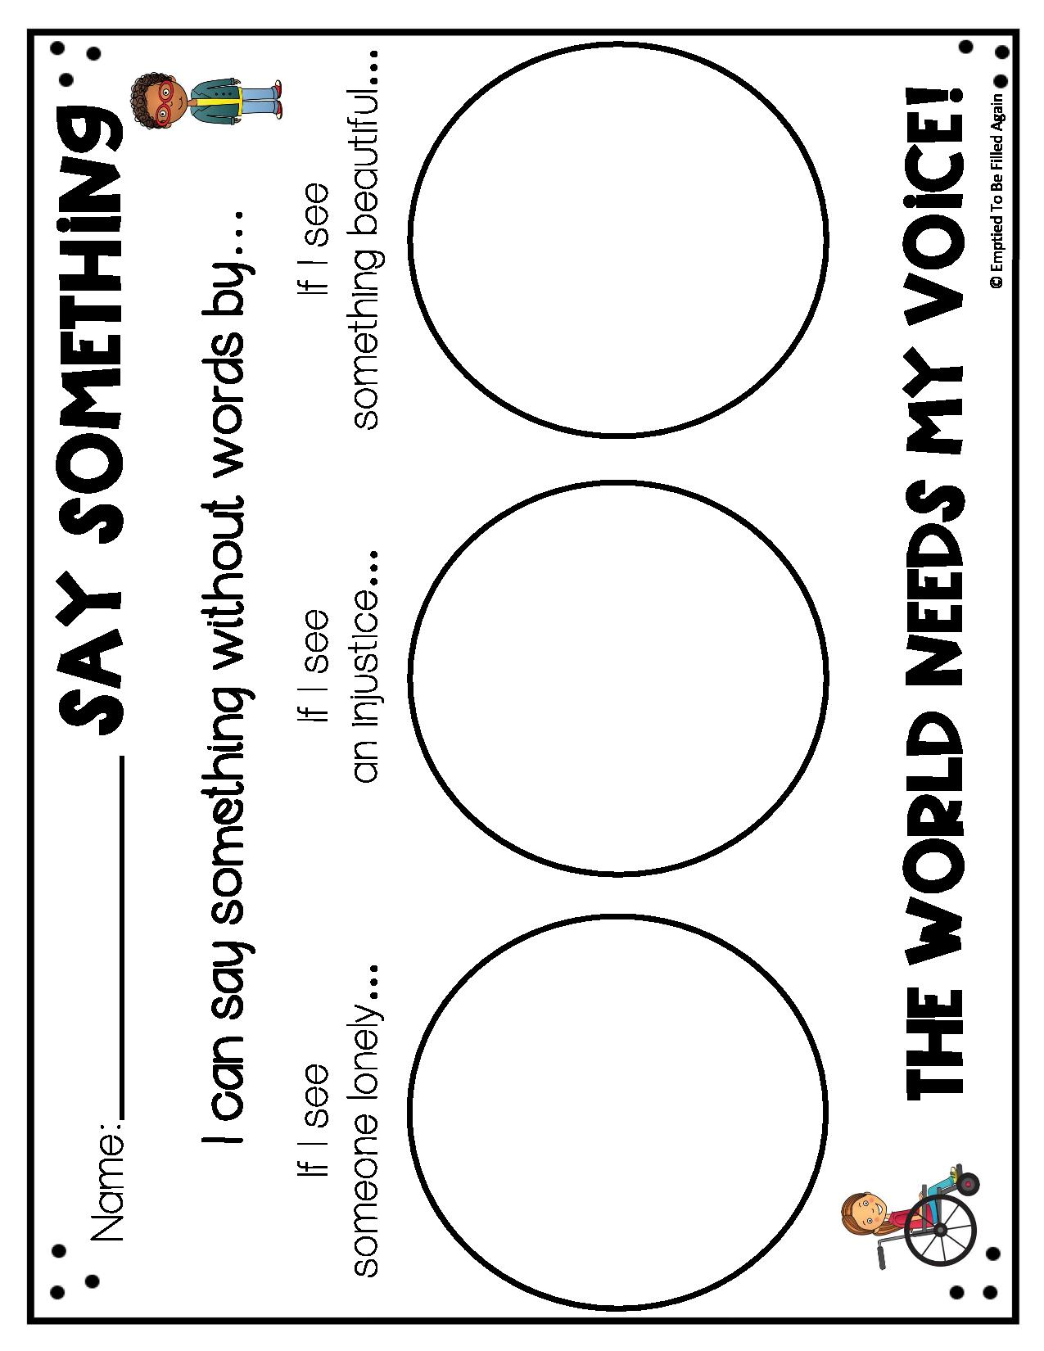

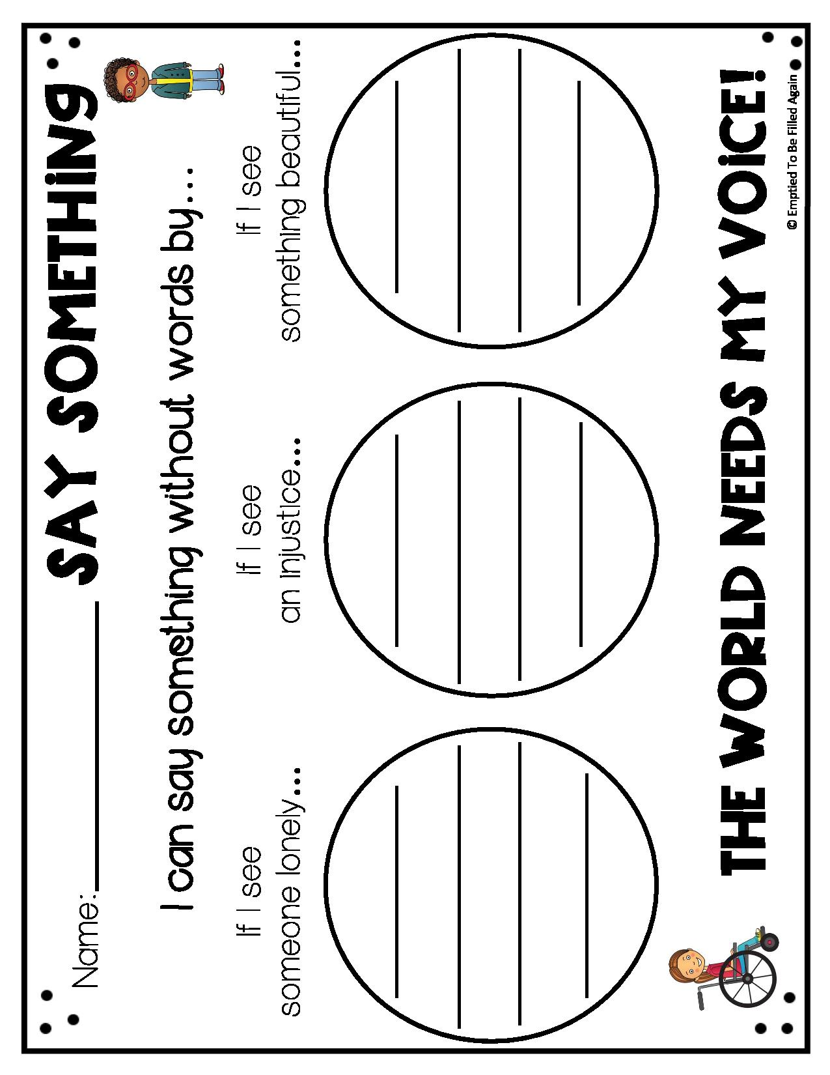

Examples of speech bubbles

Additional Extension

What Will You Say?

Your words are important! Think about what you would say if someone says the following phrases to you.

I will say….

If someone says…

Haha, he gave the wrong answer!

We broke it! What should we do?

Her hair looks so bad!

You hurt my feelings.

That kid can’t play with us!