|  |  |  |  |
| --- | --- | --- | --- |
| **Suggested Grade:**  K-2 | **Facilitator:** | **Grade:** | **Lesson Date(s):** |
| **Book Title and Author(s)/Illustrator(s):** Niño Wrestles the World, written and illustrated by Yuyi Morales | | | |
| **Theme(s)/Big Idea(s):** People have different strengths | | | |

|  |  |
| --- | --- |
| **VOCABULARY PLAN** | |
| **Focus word & kid-friendly definition:** strength – a strong or positive quality | |
| **Image/symbol:** Picture following lesson:  This is a picture of an 8-year-old boy named Tanitoluwa Adewumi. He won the New York State Chess Championship. One of his strengths is being able to play chess very well. | **Gesture:** |
| **Use in context:** Sometimes strength means being physically strong, like being able to lift something large or heavy. But today, we’re going to talk about being strength meaning something that you’re really good at. | |
| **Prompt kids to use in context:**  One of my strengths is being able to speak more than one language. Can you turn and talk to your partner about a strength that you have? | |
| **Bridge to book:** Today we are going to read a book about a little boy named Niño who shows his strength in different ways. | |

|  |  |  |
| --- | --- | --- |
| **BEFORE READING**  *write questions and student interaction (T/T, S/J, Act-it-out)* | | |
| * Review RR expectations * Introduce Book/Author/Illustrator * Teach focus vocab word ( See plan above) * Ask 1-2 questions to activate prior knowledge/ solicit predictions | | **Q1.** What is a strength that you have? Turn and talk to your partner.  *Give students ~2 minutes to talk. If necessary, remind students to switch/let their partner speak. Ask 2-3 students to share what their partner told them.*  **Additional Notes:** Explain that the book students read today will have a lot of words in Spanish that they may or may not already know. *Review these words as they come up in the reading*. Tell them that this is because the book they are reading is about a little boy named Niño who competes with different luchadores. Show them a picture of Mexico on a map as well as pictures of luchadores. |
| **DURING READING**  *write questions and vocab with page numbers and student interaction (T/T, S/J, Act-it-out)* | | |
| * Ask 3-4 questions that target different comprehension strategies (predict, infer, connect, synthesize) * Note opportunities to reinforce focus word. * Identify other potential new vocab to define while reading | **Q1.** How do you think Niño feels about the contenders? What makes you say that? Turn and talk to a partner. *Tell students to focus on the illustration if they get stuck.* (pg. 6)  *Give students ~2 minutes to talk. If necessary, remind students to switch/let their partner speak. Ask 2-3 students to share what their partner told them.*  **Q2.** What do you think Niño is going to do next? Stop and jot your answer on your whiteboards/notebooks. *Students may have the option of drawing their response instead of writing.* (pg. 8)  *Give students 2-3 minutes to draw/write. Let 2-3 students share their response.*  **Q3.** How do you think these characters feel? What makes you think that? Turn and talk to a partner. (pg. 25)  *Give students ~2 minutes to talk. If necessary, remind students to switch/let their partner speak. Ask 2-3 students to share what their partner told them.*  **Q4.** Why do you think Niño is more worried about the match with his sisters than he was he was about the other characters? (pg. 28)  *Take popcorn responses from 2-4 students.*  **Where and how will you reinforce focus word? What additional words might you address while reading?**  Lucha libre – a term used in Mexico for professional wrestling  Luchador – a professional wrestler  Temperament – a person’s attitude; how they act or speak  Superb – outstandingly excellent, impressive, or beautiful  Challenge – to invite or dare to take part in a contest  Contender – a person who competes with others  Guanajuato – a city in Mexico  Olmec – the earliest known civilization in Ancient Mexico  Opponent – a person or thing that takes the opposite position in a fight or contest  **Additional Notes:** | |
| **AFTER READING**  *write questions and student interaction (T/T, S/J, Act-it-out)* | | |
| * Ask 1 question reflecting on book theme * Make connection to extension activity | | Q1. Niño does not “defeat” his sisters like he does with the other characters. What does he do instead?  *Take popcorn responses from 2-4 students.*  Q2. What are some ways that Niño showed his strengths?  *Take popcorn responses from 2-4 students.*  **What will you say to connect theme or big idea to extension activity:**  Just like Niño, you will be creating your own luchador personalities that show off your own strengths!  **Additional Notes:** |

|  |  |
| --- | --- |
| **EXTENSION ACTIVITY** | |
| Activity Description  Students will create their own luchador trading cards. | Materials  Crayons  Pencils  Copies of luchador trading cards (found on the inside of each book)  Copies of “My Shield” graphic organizer  Copies of blank trading card template  Sample luchador card (this can be made during prep) |
| Introduction  “Just like Niño, we will be creating our own Luchador personalities!” *Show your sample card*. “To help us create these awesome cards, we are going to think about what our strengths are and what we like to do.” *Hand out “My Shield” graphic organizer.* | |
| Model  *Draw a sample shield on a large piece of chart paper. Your answers can be filled in ahead of time during prep or can be “talked through” as a model brainstorm.* | |
| Brainstorm (Whole group and/or Individual)  Allow students time to complete the graphic organizer. *The group leaders should circulate, check in with students, and help with spelling/writing as needed.* Once the students are finished, they can share out their work in small groups. **If you are following a 2-day model, collect the completed graphic organizers and continue the rest of the lesson the next day.** | |
| Instructions for Independent Work  **If you are following a 2-day model, start here. Welcome students back and review the previous lesson. If time permits, re-read the book. Hand out the completed graphic organizers.**   1. Tell students that they should choose their own luchador name based on their hobbies. For example, if a student put “sports” as a hobby, their luchador name could be, “The Athlete.” *This can be done in small groups and will likely require support from all adults in the room, particularly for younger students.* 2. Distribute the blank trading card templates. Instruct students to write in their new luchador name underneath the large empty square. When that is complete, guide them to fill out the other side of the template. Tell students to be creative when creating their “lucha style” and battle cry. Distribute the trading card copies from the book to groups that may need more help. 3. Once students have finished writing, instruct them to draw a picture of what they might look like as a luchador, including a costume. Remind them to be creative! 4. After completing the card, tell students to carefully cut around the rectangular shape so that there is no extra white border, if this has not already been removed. If it is, skip this step and proceed to next one. 5. Distribute index cards and instruct students to fold their template in half, covering the index card. This will just be used to ensure the trading cards are not flimsy. The template should be glued down to the index card on both sides so that the index card is no longer visible. Any extra bit of index card that sticks out may be trimmed off. *Younger students may need more support from the group leaders to complete this step.* | |
| Share Back and Reflection    Students can “trade” their cards by switching in pairs or small groups. Ask 3-4 students to share something interesting they notices about their classmates’ cards with the whole class.  **Take pictures of the completed cards and send them to your Literacy Manager.** | |

|  |
| --- |
| Additional Ideas for Extension Activities     * Students can create their own luchador costumes and masks. Sample masks can be found at the end of this lesson plan. |

Example of a personal strength

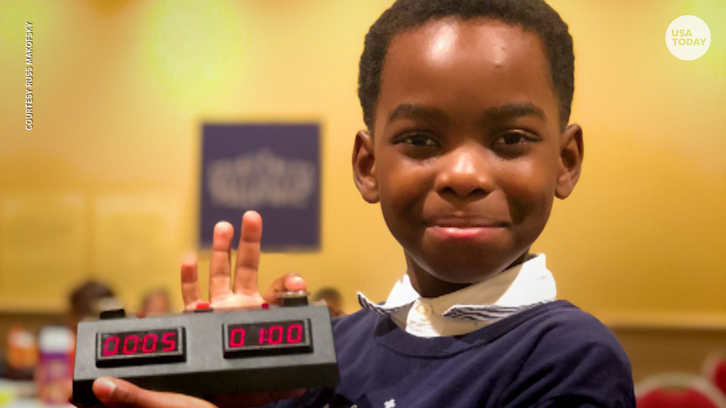

Map of United States and Mexico

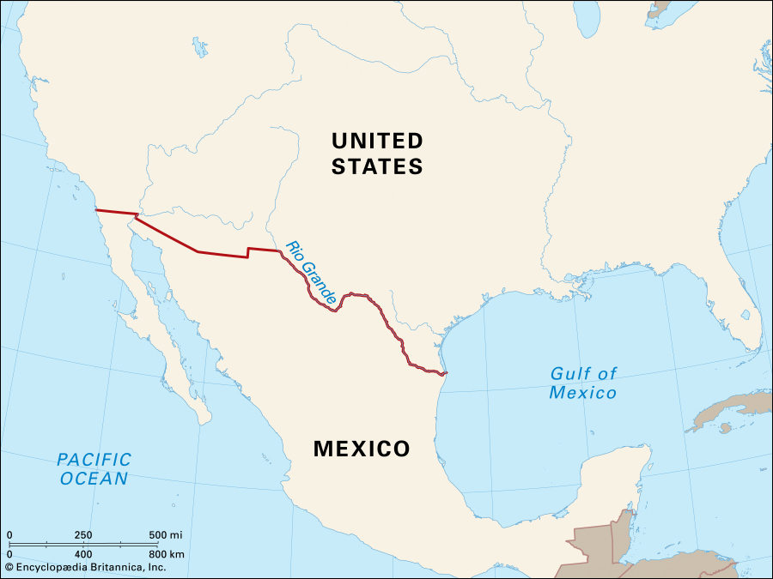

Examples of Luchadores

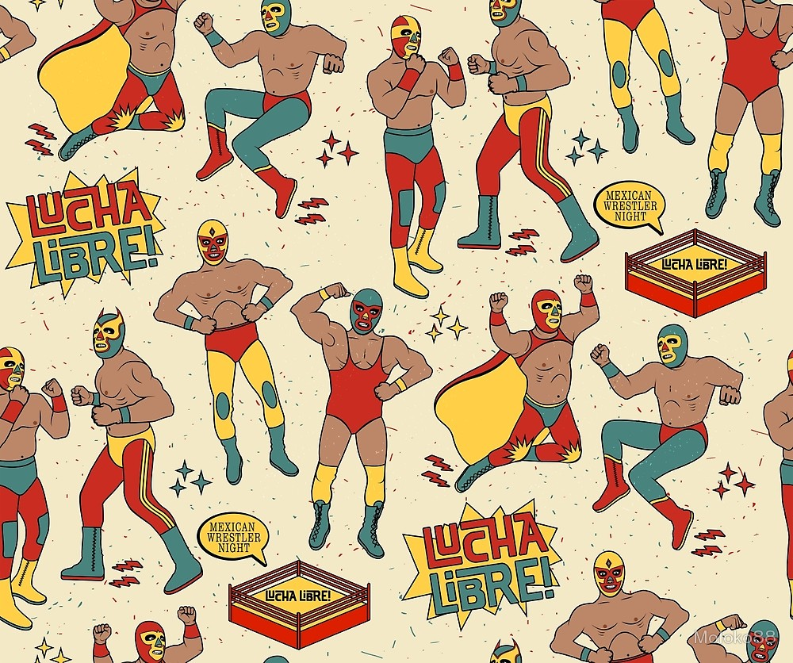

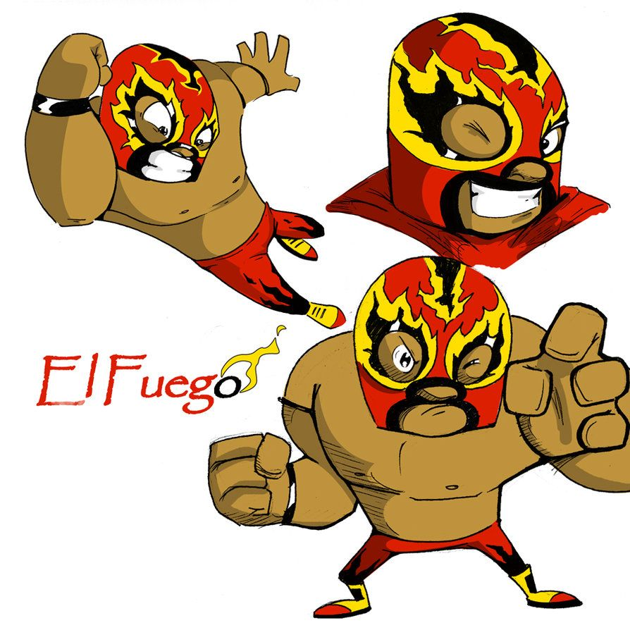

**My Shield**



**My strengths:** *What I am good at*

**Self-portrait:** *What I look like*

**Goals:** *What I want to do*

**Hobbies:** *What I like to do*

