|  |  |  |  |
| --- | --- | --- | --- |
| **Suggested Grade:** 1st-3rd | **Facilitator:** | **Grade:** | **Lesson Date(s):** |
| **Book Title and Author(s)/Illustrator(s):** Last Stop on Market Street - Author: Matt de la Peña; illustrator: Christian Robinson | | | |
| **Theme(s)/Big Idea(s):** Beauty is all around us; we have something to learn from our elders; helping our community is important | | | |

|  |  |
| --- | --- |
| **VOCABULARY PLAN** | |
| **Focus word & kid-friendly definition:** Neighborhood - the part of the city where someone lives (including people, stores, and outdoor spaces) | |
| **Image/symbol:** see attached images | **Gesture:** n/a |
| **Use in context:** I enjoy walking my dog around my neighborhood and saying hello to people we pass on the street. | |
| **Prompt kids to use in context:** What do you see in your neighborhood? | |
| **Bridge to book:** In The Last Stop on Market Street, C.J. and his Nana travel through through their neighborhood on a bus and meet many interesting people. | |

|  |  |  |
| --- | --- | --- |
| **BEFORE READING**  *write questions and student interaction (T/T, S/J, Act-it-out)* | | |
| * Review RR expectations * Introduce Book/Author/Illustrator * Teach focus vocab word ( See plan above) * Ask 1-2 questions to activate prior knowledge/ solicit predictions | | This book is set in a boy named CJ’s neighborhood. A neighborhood means the part of a  city where we live. *Show image and use word in context (see above).*  **Q1.** What do you see in your neighborhood? On your whiteboards, make a list (1st grade: draw a picture) of what you see in your neighborhood.  *Give students ~2 mins to stop & jot. Ask 3 students to share their responses (~3 mins)*.  **Q2.** Look closely at the cover of this book. Turn and talk with a partner about what you think CJ is going to do in his neighborhood.  *Give students ~2 mins to talk. If necessary, remind students to switch/let their partner speak. Ask 2-3 students to share what their partner told them.* |
| **DURING READING**  *write questions and vocab with page numbers and student interaction (T/T, S/J, Act-it-out)* | | |
| * Ask 3-4 questions that target different comprehension strategies (predict, infer, connect, synthesize) * Note opportunities to reinforce focus word. * Identify other potential new vocab to define while reading | **Q1.** Pg. 5 - Make a face to show me how CJ is feeling right now.  *Call out the faces you see students making. For example: “I notice you are making a sad or frustrated face. I agree that CJ seems sad and frustrated right now.”*  *Optional: Follow up by asking a quick question to all students - why is CJ feeling sad and frustrated right now? Take 1-2 popcorn responses.*  **Q2.** Pg. 13 - Nana tells CJ that some people watch the world with their ears. If you closed your eyes in your neighborhood, what is a sound that you would hear? How do you “watch the world with your ears”? Stop and jot what you hear on your whiteboards (1st grade: draw a picture of what you hear).  *If necessary, give an example - “In my neighborhood, I can hear the ice cream truck in the summer and dogs barking.” Give students ~2 mins to stop and jot. Ask 2 students to share their examples.*  **Q3.** Pg. 18 - What gives CJ the feeling of magic? Turn and talk with a partner about what you think. Tell them what part of the story made you think so.  *Give students ~3 minutes to talk. Listen for students discussing that the music played by the guitar player makes CJ feel that way. They should remember that on the previous page, it said that “the guitar player was already plucking strings and beginning to sing.” If time, take 2-3 student responses.*  **Q4.** Pg. 25 - Turn and talk with your partner - what makes CJ feel glad that he came?  *Give students ~2 minutes to talk. Students should talk about how CJ is glad he came because he sees people that he knows. The people in the window are the people that Nana mentioned earlier - Bobo, the Sunglass Man, and Trixie. Help students make this connection by asking probing questions such as - who did Nana say they were planning to visit earlier?*  **Q5.** Pg. 27- Look at the picture. What are CJ and Nana doing?  *Take 1-2 popcorn responses. Students should note that they are serving food to people at a soup kitchen.*  **Where and how will you reinforce focus word? What additional words might you address while reading?**   * Reinforce focus word in Q2 as well as during after reading questions and extension activity. * Pg. 25 - note for students while reading that *familiar* means someone you know well * Pg. 23 - when reading the word *arcing*, mime drawing an arc in the air   **Additional Notes:**   * On page 15, point out for students that when CJ says “Sure wish I had one of those,” he is referring to the iPhone or iPod the two boys are listening to. Some students might not catch that reference or be able to see that illustration if they are sitting in the back. | |
| **AFTER READING**  *write questions and student interaction (T/T, S/J, Act-it-out)* | | |
| * Ask 1 question reflecting on book theme * Make connection to extension activity | | **Q1.** Was your prediction about what CJ was going to do in his neighborhood correct or not? Give me a thumbs up, thumbs down, or thumbs in the middle to show how correct your prediction was.  **Q2.** Thinking about where CJ and Nana actually went (the soup kitchen), turn and talk with a partner about the lesson that you think CJ learned from Nana.  *Give students ~3 minutes to discuss. Students should talk about how CJ learned how important it is to help your neighborhood or community. Students can also talk about how CJ learned that you can find beauty anywhere and that it is important to pay attention to the world around you. Take 2-3 student responses.*  **What will you say to connect theme or big idea to extension activity:**  Tell students that CJ learned how important it is to notice the beauty of your neighborhood and what makes it unique. His Nana and the passengers on the bus helped him see, hear, and smell different things in his neighborhood.Today we are going to think about our neighborhoods and what makes them special. Then we are going to write a poem about our neighborhood! |

|  |  |
| --- | --- |
| **EXTENSION ACTIVITY** | |
| **Activity Description**  Five Senses Neighborhood Poem - students brainstorm what is related to each of the five senses in their neighborhood. They use this brainstorming to create an original poem. | **Materials**   * My Neighborhood Poem example written on a piece of chart paper * My Neighborhood Brainstorming Chart drawn on a piece of chart paper * My Neighborhood Brainstorming Chart (one per student) * My Neighborhood Poem template or writing notebook (one per student) * Pencils |
| **Introduction**  Tell students that as we discussed after reading the book, CJ learned to notice and appreciate the interesting and beautiful things in his neighborhood. Today we’re going to think about our own neighborhoods. Then we are going to brainstorm things in our neighborhood using our five senses. Then we are going to write a poem! | |
| **Model**  Read students the My Neighborhood Poem example (see below) or one of your own that you wrote in the same style. Ask students and take quick popcorn answers after each question: What did the author of this poem see in his/her neighborhood? What did he/she hear? Smell? Taste? Touch? | |
| **Brainstorm** (Whole group and/or Individual)  Ask students to help you think of things that they can hear, see, smell, taste, or touch in their neighborhoods. Use the My Neighborhood Brainstorming Chart on a piece of chart paper to record their ideas. Help students come up with detailed ideas and examples (for example: if a student says “I see a tree” push them to describe the tree “I see a green, leafy tree” or “I see a tree filled with purple blossoms.”) After recording a few examples in each category as a whole group, hand out individual brainstorming sheets. Have students brainstorm some more on their own. | |
| **Instructions for Independent Work**  After brainstorming, tell students that they should put their brainstorming ideas into a poem format. Reread the example poem if necessary and note for students how lines of the poem start with “I see…” “I hear…” etc. and that they should copy this structure in their poem. Hand out My Neighborhood Poem templates or have students record their poems in their notebooks. | |
| **Share Back and Reflection**  After writing poems, have students read their poems to a partner. If time, allow 3-5 students to read their poems to the entire class.  *Reflection Question:* With a partner finish this sentence - In his neighborhood CJ ________________. In my neighborhood I ________________________. Each partner should take turns finishing the sentences.  *Optional:* Have students copy final versions of their poems onto a nice piece of paper and make My Neighborhood Poem books for the entire class to take home by photocopying all of the poems together. Let students add drawings and illustrations if time. | |

|  |
| --- |
| **Additional Ideas for Extension Activities**  Readers Theater - see attached. |

**VOCABULARY IMAGE - NEIGHBORHOOD**

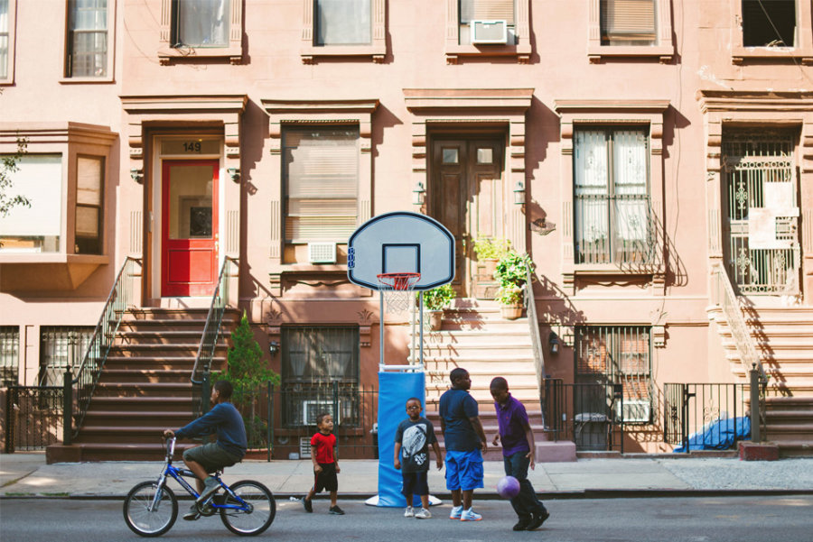

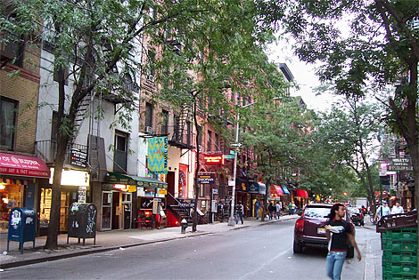

**My Neighborhood Example Poem**

I see golden sunflowers in the middle of the street

and the bright blue building at the corner of St. Marks

I taste spicy curry chicken, rice, and peas

I hear skateboards on the sidewalk,

the bus slowing down at the corner,

and my dog barking at squirrels in the park

I smell stinky garbage on the street

and sweet buttery croissants from Frenchy’s food truck

I feel the shiny smooth doorknob that tells me I’m home

**Brainstorm the Five Senses in Your Neighborhood**

|  |  |
| --- | --- |
| **Things I see** |  |
| **Things I hear** | Image result for ear clipart |
| **Things I smell** |  |
| **Things I taste** |  |
| **Things I touch** |  |

**My Neighborhood Poem**

Author: __________________________________________

_____________________________________________________________

_____________________________________________________________

_____________________________________________________________

_____________________________________________________________

_____________________________________________________________

_____________________________________________________________

_____________________________________________________________

_____________________________________________________________

**Last Stop on Market Street Readers Theater**

*Characters:* **Narrator 1 CJ Nana** **Narrator 2** **Narrator 3** **Mr. Dennis**

**-----------------------------------------------------------------------------------------**

**NARRATOR 1**: CJ pushed through the church doors, skipped down the steps. The outside air smelled like freedom, but it also smelled like rain, which freckled CJ’s shirt and dripped down his nose.

**CJ:** “How come we gotta wait for the bus in all this wet?”

**NANA:** “Trees get thirsty too. Don’t you see that big one drinking through a straw?”

**NARRATOR 2:** From the bus stop he watched water pool on flower petals. Watched rain patter against the windshield of a nearby car. His friend Colby climbed in, gave CJ a wave, and drove off with his dad.

**CJ:** “Nana, how come we don’t get a car?”

**NANA**: “Boy, what do we need a car for? We got a bus that breathes fire and old Mr. Dennis, who always has a trick for you.”

**NARRATOR 3**: The bus creaked to a stop in front of them. It sighed and sagged and the doors swung open. They sat right up front. The man across the way was tuning a guitar. An old woman had butterflies in a jar. Nana gave everyone a great big smile and a “good afternoon.” She made sure CJ did the same.

**CJ:** “How come we always gotta go here after church? Miguel and Colby never have to go nowhere.”

**NANA:** “I feel sorry for those boys. They’ll never get a chance to meet Bobo or the Sunglass Man. And I hear Trixie got herself a brand new hat.”

**NARRATOR 1**: CJ stared out the window feeling sorry for himself. He watched cars zip by on either side, watched a group of boys hop curbs on bikes. A man climbed aboard with a spotted dog.

**CJ:** “How come that man can’t see?”

**NANA:** “Boy, what do you know about seeing? Some people watch the world with their ears.”

**NARRATOR 2:** Two older boys got on next. CJ watched as they moved on by and stood in back.

**CJ:** “Sure wish I had one of those.”

**NANA:** “What for? You got the real live thing sitting across from you. Why don’t you ask the man if he’ll play us a song?”

**NARRATOR 3:** CJ didn’t have to. The guitar player was already plucking strings and beginning to sing. Nana closed her eyes to feel the magic of the music. So did CJ and the spotted dog.

**NARRATOR 1:** And in the darkness the rhythm lifted CJ out of the bus, out of the busy city. He saw sunset colors, swirling over crashing waves. Saw a family of hawks slicing through the sky. Saw the old woman’s butterflies dancing free in the light of the moon. CJ’s chest grew full and he was lost in the sound and the sound gave him the feeling of magic.

**NARRATOR 2:** The song ended and CJ opened his eyes. Everyone on the bus clapped, even the boys in back. Nana glanced at the coin in CJ’s palm. CJ dropped it in the man’s hat.

**MR DENNIS (THE BUS DRIVER):** “Last Stop on Market Street!”

**NARRATOR 3:** CJ looked around as he stepped off the bus. Crumbling sidewalks and broken-down doors, graffiti-tagged windows and boarded-up stores.

**CJ:** “How come it’s always so dirty over here?”

**NANA:** “Sometimes when you’re surrounded by dirt, CJ, you’re a better witness for what’s beautiful.”

**NARRATOR 1**: CJ saw the perfect rainbow arcing over their soup kitchen. He wondered how his Nana always found beautiful where he never even thought to look.

**NARRATOR 2:** He looked all around them again, at the bus rounding the corner out of sight and the broken streetlamps still lit up bright and the stray-cat shadows moving across the wall. He spotted familiar faces in the window.

**CJ:** “I’m glad we came.”

**NANA:** “Me too, CJ. Now, come on.”

*adapted from Last Stop on Market Street by Matt de la Peña and Christian Robinson*